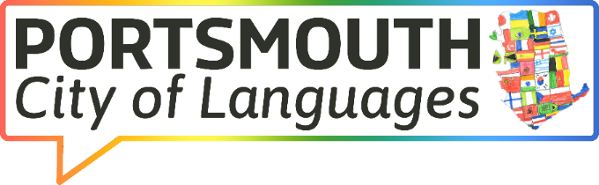
Meeting: Partners' Group
Date: Friday 29th November 2024
Time: 13.00 - 14.00

AGENDA

MS Teams Meeting Link: Join the meeting now
This is a joint initiative launched by the city’s language providers, the Local Authority and other interested groups to showcase good practice in language provision at all levels, signpost to resources and develop networks, as well as celebrating languages in the city.

NO. | ITEM | LEAD
1. | Welcome and apologies | Karen T
2. | Introduction to the rationale of the initiative: Portsmouth ~ City of Languages (including logo) | Steering Group (KT, LL, PJ, DA)
3. | Updates from the steering group and partners  - PEP website (KT)  - Solent Language Hub and the national context (LL)  - Community Languages, British Sign language (KT)  - Awards e.g. International Schools, Language Friendly Schools (LL) | KT/LL
4. | Cities of languages and a strategic approach | KT (on behalf of Tanya R)
5. | Opportunities for the future (contributions from everyone)  - Celebrating Languages in Portsmouth Week (17- 21 March 2025)  - Cross-phase Languages Conference (2nd July 2025)  - Any other ideas welcome | All
6. | AOB  Date and time of next meeting | KT

Portsmouth ~ City of languages (logos)
Please feel free to use as appropriate

