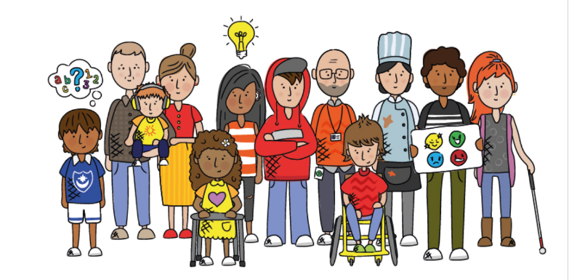

**Portsmouth Special Educational Needs and Disabilities (SEND) partnership update**

**Issue 1: December 2020**

**Introductory message from Julia Katherine**

Welcome to our first SEND Partnership update.

This is an update for all the professionals across education, health, care and the voluntary and community sector who work with the approximately 4,000 Portsmouth children and young people aged 0 to 25 with SEND and their families.

If there are any aspects of this work you would like to know more about or would like to get involved with, please let me know at [Julia.Katherine@Portsmouthcc.gov.uk](mailto:Julia.Katherine@Portsmouthcc.gov.uk)

**SEND Awareness Introduction e-learning module**

If you work with children or young people, you can now enrol on a new special education needs and disabilities (SEND) e-learning course.

On the course, you will gain an understanding of special educational needs and disabilities (SEND), how needs are identified and how support can be put in place.

You can access the course [here](https://pcc.portsmouthlearninggateway.org.uk/elearning/Course/Detail?CourseId=266).

**National updates**

Please see the links below for the latest national updates:

* [Ministerial letter from Vicky Ford](https://portsmouthlocaloffer.org/an-open-letter-from-vicky-ford-mp-parliamentary-under-secretary-of-state-for-children-and-families/)
* SEND & BAEA Newsletter - November 2020 
* [Ofsted reports from Autumn term visits](https://assets.publishing.service.gov.uk/government/uploads/system/uploads/attachment_data/file/933499/SEND_COVID-19_briefing_October_2020.pdf)
* [Guidance for full opening: special schools and specialist settings](https://www.gov.uk/government/publications/guidance-for-full-opening-special-schools-and-other-specialist-settings/guidance-for-full-opening-special-schools-and-other-specialist-settings)

**SEND Strategy**

The Portsmouth SEND Strategy aims to promote inclusion and improve the outcomes for Portsmouth children and young people aged 0-25 years with SEND and their families.

It is governed and delivered by the following multi-agency structure

It aims to achieve increased percentages of children and young people with SEND who are able to:

1. Be included within their local community,

2. Lead healthy lives and achieve wellbeing,

3. Learn and make progress,

4. Make and maintain positive relationships within their family and community

5. Participate in education and training post-16 and prepare for employment

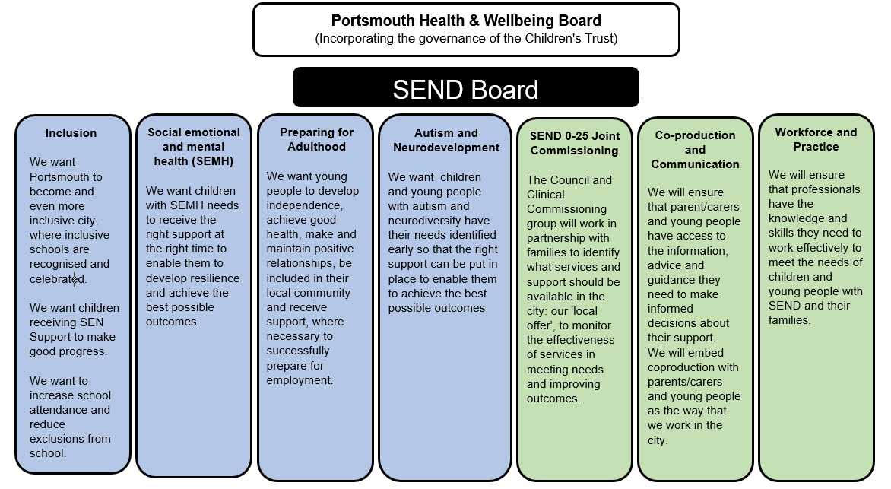

**[Local Offer](https://portsmouthlocaloffer.org/)**  
   
Portsmouth 'local offer' is a website for professionals and families where you can find all the information you need about SEND in one place. It includes SEND national and local updates, guidance and key document for both professionals and families, as well as information about all of the education. Health, care and leisure services available in the city for children and young people with SEND and their families.

If you have a question about SEND, have a look on the local offer website for the answer.

You can also follow us on social media [](https://www.instagram.com/portsmouthlocaloffer/) [](https://www.facebook.com/PortsmouthSEND/) [](https://twitter.com/SENDlocal)

[**Praise for SEND services for children and young people in Portsmouth**](https://www.portsmouth.gov.uk/2020/10/09/praise-for-send-services-for-children-and-young-people-in-portsmouth/)  
   
Parents and carers praised the support they get from Portsmouth keyworkers and schools for their children with special educational needs and disabilities (SEND) in Portsmouth City Council’s annual survey, run in collaboration with Portsmouth Parent Voice and the Dynamite youth group. The survey ran from January to March 2020, prior to the coronavirus pandemic, and showed that a large majority of respondents believe their views are listened to by professionals (80%) and over two-thirds of respondents who feel that their child or young person needs SEND support know how to access it (68%).

Conversations with young people in Portsmouth over the age of 13 with SEND highlighted that they feel they are able to be more independent and are given the opportunity to learn vital skills such as how to cook, how to tell the time and how to travel safely.

A clear majority of the young people engaged with agree that they ‘receive good support for their mental health’. Similarly, young people feel they are given the right amount of opportunity to meet friends and socialise which helps in building a strong support network of like-minded peers. Most of the young people strongly felt that they are being provided with good educational support so that more options will be available to them in the future.

The survey results come at a time when the council have invested in improvements to two schools in Portsmouth to enable them to manage the changing complexity of SEND pupils.  For pupils with complex learning difficulties who may also have autism, at Cliffdale Primary Academy a £2m extension now provides additional teaching accommodation and improved external play areas for primary school pupils and at Redwood Park Academy additional classrooms and music and drama space have been added in a £3m extension for secondary school pupils.

To read the full report and for information, support and local services on offer for children and young people in Portsmouth up to age 25 with SEND, please visit the new Portsmouth SEND Local Offer website at <https://portsmouthlocaloffer.org/sendsurvey2020>

Kate Bradley, mother of two boys said:

“I have had lots of support with both my children. Lucas, my youngest son, didn’t cope well in mainstream school. He got his Education, Health and Care (EHC) plan during lockdown and is now in the Inclusion Centre at Portsdown Primary School. He is so happy being there. For the first time ever he got star of the week!

“During lockdown my eldest son, Jake, who has autism, was only at school part time but is very happy now be back full time at Redwood Park School.”

Cllr Suzy Horton, Cabinet Member for Education at Portsmouth City Council, said:

“We are very grateful to those who took part in the survey and delighted with the positive feedback from Portsmouth families about the support they are getting for children and young people with SEND. The demand for services for young people with special needs and disabilities continues to grow and we are always listening and looking for more ways to improve, so direct input like this is really welcome.”

**Portsmouth Inclusion Conference 2020:**

**Portsmouth schools going the extra mile for children with special educational needs**

Portsmouth City Council's first online Portsmouth Inclusion Conference was held on 22 October, celebrating the continued commitment by Portsmouth schools to high quality support for children with special educational needs and disabilities (SEND).

Teachers, education staff and other professionals who work with children with SEND attended the conference, which is normally held face to face but was moved online this year due to the pandemic. Keynote speakers were Ian Hunkin, Director of the Sigma Teaching School, and Jarlath O'Brien, behaviour columnist for the Times Educational Supplement.

With more than 4,000 children and young people in Portsmouth needing extra assistance for conditions such as anxiety, autism, ADHD or visual and other physical impairments, the demand for SEND support is increasing, and the ability for schools to support them is vital as it allows the children to be part of their community, to develop a sense of belonging and become better prepared for life in the community as children and adults.

Cllr Suzy Horton, Cabinet Member for Children, Families and Education at Portsmouth City Council, said: "It was fantastic to see so many people attending the online conference and demonstrating the commitment to providing a high and consistent standard of education which is accessible to all their pupils, no matter what their special educational needs or disabilities might be. We want to encourage every child's talents and I thank all staff and professionals who have done a tremendous job in supporting pupils, particularly this year."

The first online conference comes in the year that a unique new scheme was launched by Portsmouth City Council, designed to help schools work with each other to provide the best possible support to children. The new peer assessment scheme, the Portsmouth Inclusive Education Quality Mark (PIE QM), addresses this need and helps schools to learn from each other and share best practice.

A recent survey of Portsmouth parents and carers of children with SEND showed that a large majority of respondents believe their views are listened to by professionals (80%) and over two-thirds of respondents who feel that their child or young person needs SEND support know how to access it (68%).

Information about the PIE QM scheme and other support and local services for those working with children and young people with SEND, can be found on the Portsmouth SEND Local Offer website at [www.portsmouthlocaloffer.org](http://www.portsmouthlocaloffer.org)  
 

