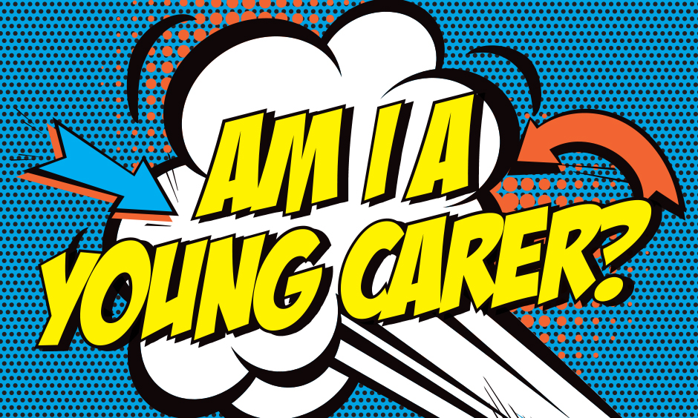
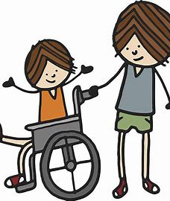
Do you look after or help to look after someone in your family who has:
- A disability?
- A long-term illness?
- A mental health condition?
- Drug or alcohol misuse?
If so you're a young carer.
Perhaps you're not a young carer, but you know someone who might be? Why not tell them about this display?
Being a Young Carer can sometimes be great
Young carers:
- Help their family;
- Spend lots of time with them;
- Build close relationships with them;
- Learn important things that will help them when they grow up.
It can also sometimes be hard work
It might:
- Take up a lots of a young carers free time;
- Make it difficult for them to spend time with their friends;
- Make them feel worried… angry… or tired;
- Make it difficult for them to get homework done or concentrate in school.
It's a good idea for a young carer to talk to someone in their school about their caring role and how it makes them feel.
At (your school) young carers can talk to:
- Their teacher or teaching assistant;
- (Your well-being staff)
- Any adult they feel comfortable talking to.

Young Carers in Portsmouth can also get help from Portsmouth Young Carers Service (PYCS)

PYCS give young carers lots of opportunities to meet with other young carers through:
- Weekly groups;
- School holiday activities including cinema, adventure playground and museum visits, art activities and special projects.

Through these activities young carers can:
- Have a break from their caring role;
- Have a chance to speak to someone and be listened to;
- Learn new skills and try new activities.

PYCS can also offer extra help if young carers are finding it difficult to manage their caring role, school or their relationships with family and friends.
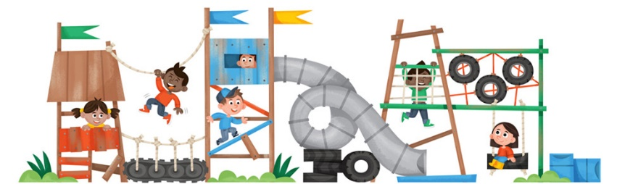
youngcarers@secure.portsmouthcc.gov.uk
For more information about young carers and the help available for them look at these websites:
