Maths Activities without the need to prepare ahead
Contents
Year 1 and 2 - Addition and subtraction picture colouring
Addition and subtraction colouring picture (2)
Find the objects counting to 20
^{2D shape colouring}
^{Spring tally chart}
Year 3 and 4 – Multiplication spring pattern
^{Hidden eggs coordinates}
Year 5, 6 and 7 – Calculation Code Cracker
Maths colouring mosaic with negative numbers and decimals
^{Easter egg fraction ordering}
^{Place value code cracker}
^{Percentages code cracker}
^{Multiplication code cracker}
Open investigation for all - rocket investigation and squares investigation (Spectrum maths – a blast from the past!)
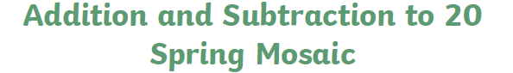
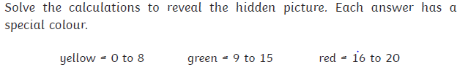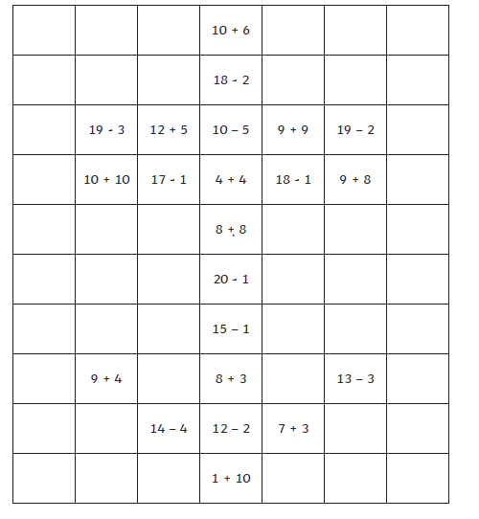
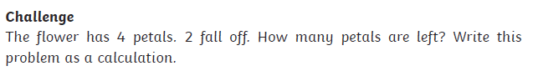
Can you make up some sums for blue that have an answer of 21, 22, 23, 24 or 25 so you can colour the background?
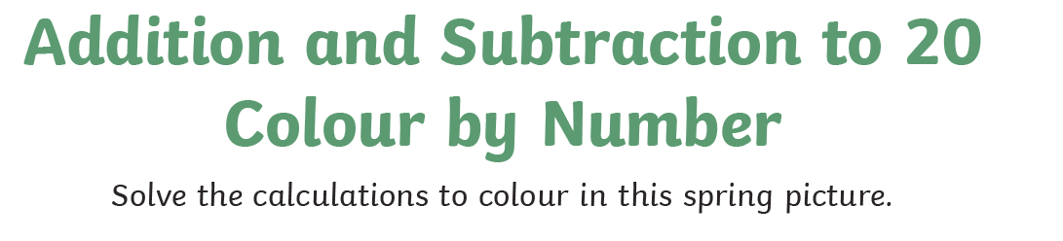
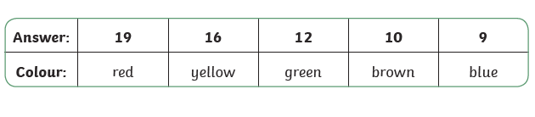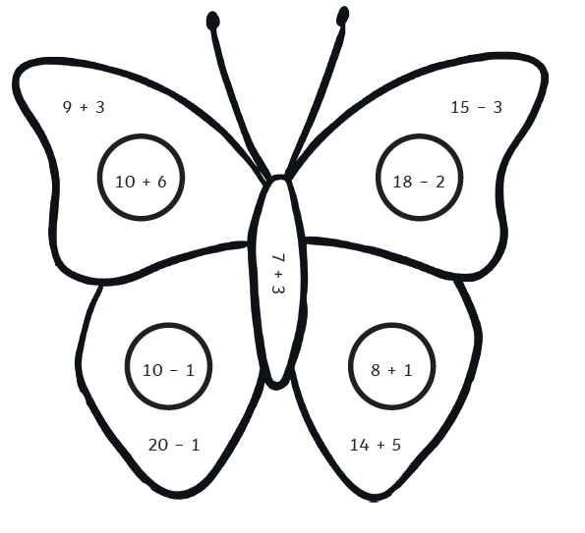
Can you design your own butterfly?

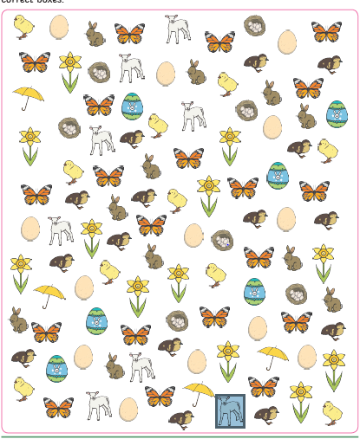

Record your answers on the next page.
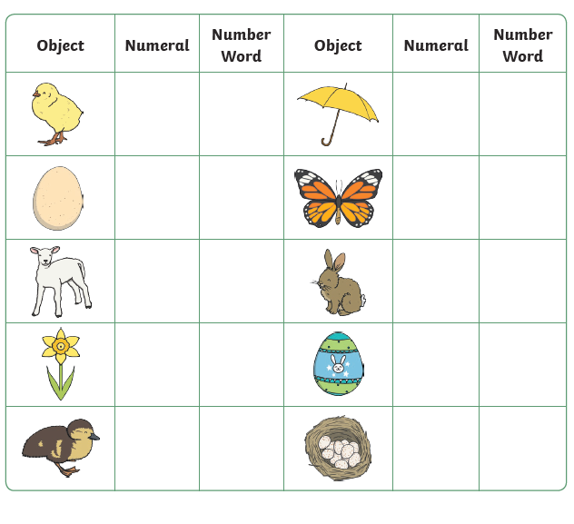

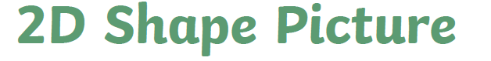

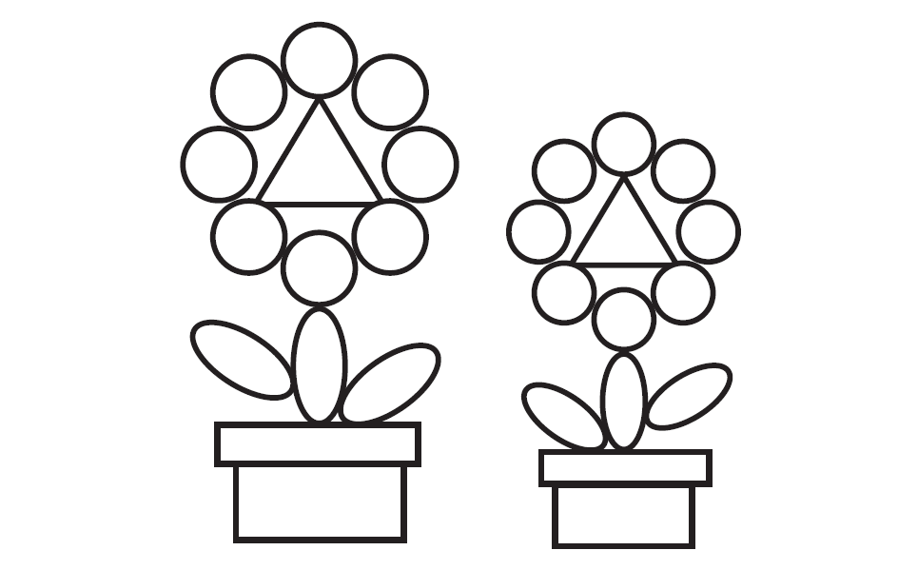
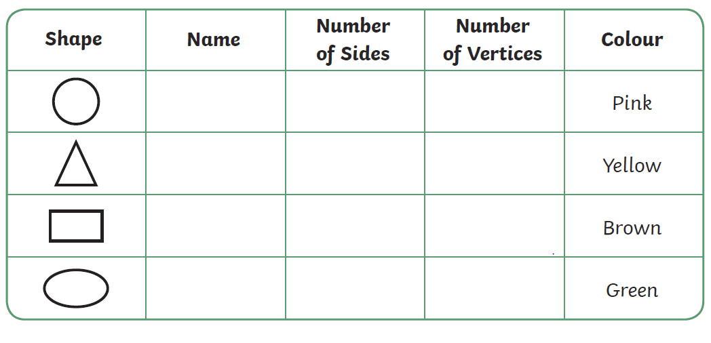
Can you make your own shape pattern to colour? You could even make you own colour code for each shape.
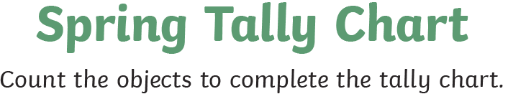

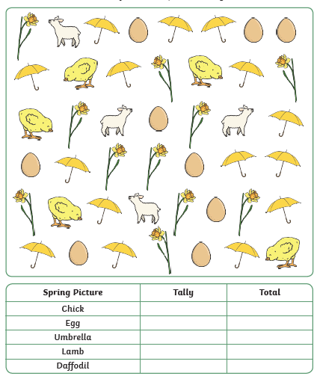
Can you tally other things you can see in the classroom or outside? Make your own chart.
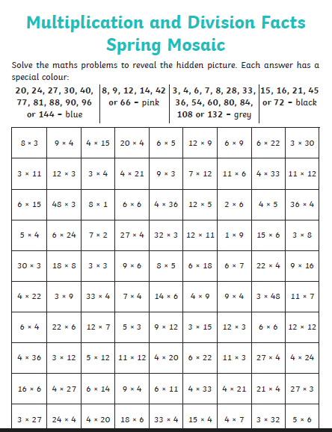

Try making one of your own
OR
Put any times tables into a grid and, using the colours above, and see what your pattern comes out like!

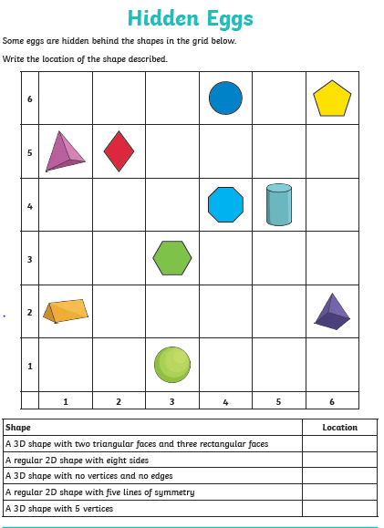
Now add some of your own shapes and write the location
Shape | Location

Calculation Code Cracker

To crack the code and solve the mystery you will need to perform each of the calculations below. You can ask the Super Computer (your teacher) to swap answers for letters after every 5 questions you complete. The Super Computer has been programmed by some of the best Mathematical minds in the country and will turn your answers in to letters (because they have the answer sheet).
Hurry, time is of the essence and lives are at stake!
1. | 107 + 210 | 2. | 456 – 281
3. | 6 × 8 | 4. | 105 ÷ 5
5. | 48 + 36 + 29 | 6. | 458 – 221
7. | 3 × 25 | 8. | 48 ÷ 3
9. | 214 + 97 | 10. | 3² × 12
11. | ⅔ of 240 | 12. | 50% of 280
13. | 111+ 119 + 235 | 14. | 1003 - 462
15. | 48 ÷ 4 | 16. | 7²
17. | 10% of 250 | 18. | a + 2b (when a = 7, b = 5)
19. | 14 × 11 | 20. | 2141 - 418
21. | 416 + 219 + 83 | 22. | 20% of 600
23. | ⅛ of 800 | 24. | 56 ÷ 4
25. | 9 × 8 | 26. | 25% of 180
27. | 4.5 × 6 | 28. | 21 × 12
29. | 117 ÷ 9 | 30. | 2x – y (when x = 20, y = 2)
31. | 42 + 35 + 27 + 28 | 32. | 122 + 52 - 43
33. | 246 - 58 | 34. | 2³
35. | 0.4 × 360 | 36. | 15% of 200
37. | 2³ × 5² | 38. | If 2x + 5 = 25 then x = ?
39. | Number of days in a week × Number of months in a year | 40. | 200 ÷ 5
41. | 22 × 15 | 42. | Number of cards in a pack – Number of days in April
43. | ⅜ of 40 | 44. | 6² + 5
45. | 0.5 × 360 | 46. | 3c + 4d (when c = 5, d = 6)
47. | ⅔ of 75 | 48. | 215 + 211.5
49. | 2% of 1000 | 50. | 5% of 60
51. | 2107 + 206 + 11 | 52. | 3217 – 1294
53. | 16 × 18 | 54. | 210 ÷ 4
55. | 4² + 36 + 2³ | 56. | 17% of 200
57. | 13 × 27 | 58. | 171 ÷ 3
59. | 2101 + 198 | 60. | 6² ÷ 1²
61. | ¾ of 280 | 62. | 70% of 550
63. | 413 + 117 - 226 | 64. | 908 – 462
65. | 124 ÷ 8 | 66. | 11²
67. | 3% of 250 | 68. | a(3 + 2b) (when a = 6, b = 5)
69. | 198 × 3 | 70. | 125% of 180
71. | 48 × 5 | 72. | 21% of 160
73. | ⅓ of 84 | 74. | 2150 ÷ 5
75. | 19 × 18 | 76. | 0.3 × 1000
77. | 5.5 × 11 | 78. | 110 × 17
79. | 1026 ÷ 9 | 80. | 5v + w (when v = 4, y = -2)
81. | 1937 + 2069 - 48 | 82. | 3² × 4²
83. | 118.9 – 12.7 | 84. | 6³
85. | 125 ÷ 0.5 | 86. | 98% of 300
87. | 2² × 5² × 6 | 88. | If 3a - 9 = 24 then a = ?
89. | Number of players in football team × Number of days in May | 90. | 480 ÷ 15
91. | 232 × 14 | 92. | 572 ÷ 11
93. | ⅜ of 888 | 94. | 9² + 4
95. | 0.8 × 420 | 96. | 3(e + 2f) (when e = 8, f = -3)
97. | ⅔ of 3600 | 98. | 1579.2 + 356.8
99. | 82% of 400 | 100. | 0.7 × 10² × 3²
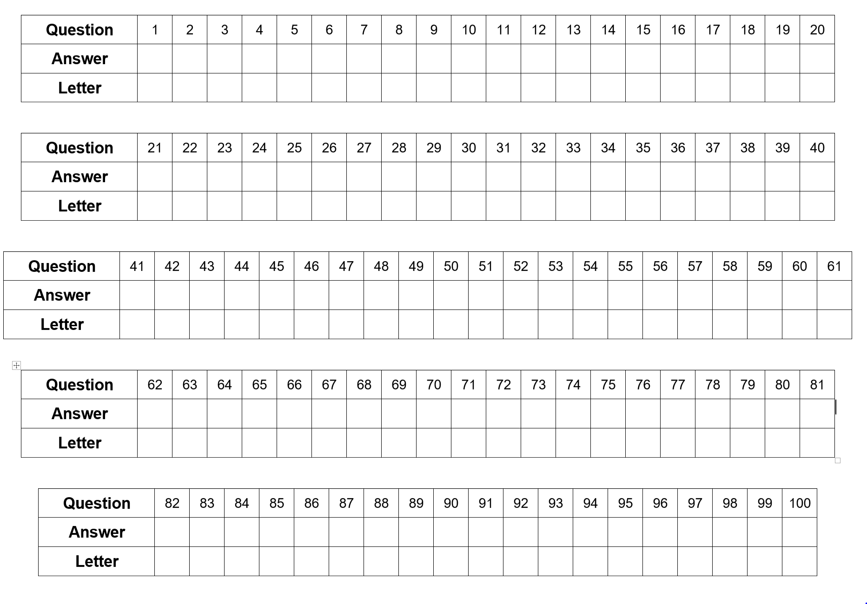
Code Cracker Super Computer for the teacher not the children – give them a few letters at time to see if they can work out the message.

For instance H = 317, 12, 100, 30 and 18
L = 48, 21, 311, 25
A blank space = 75, 541, 1723, 120, 27, 131, 144, 40, 41, 3, 2324, 2299 ….
You might also want to put a teddy in a cupboard with an X on the door so the message has a purpose!
Answers for the teacher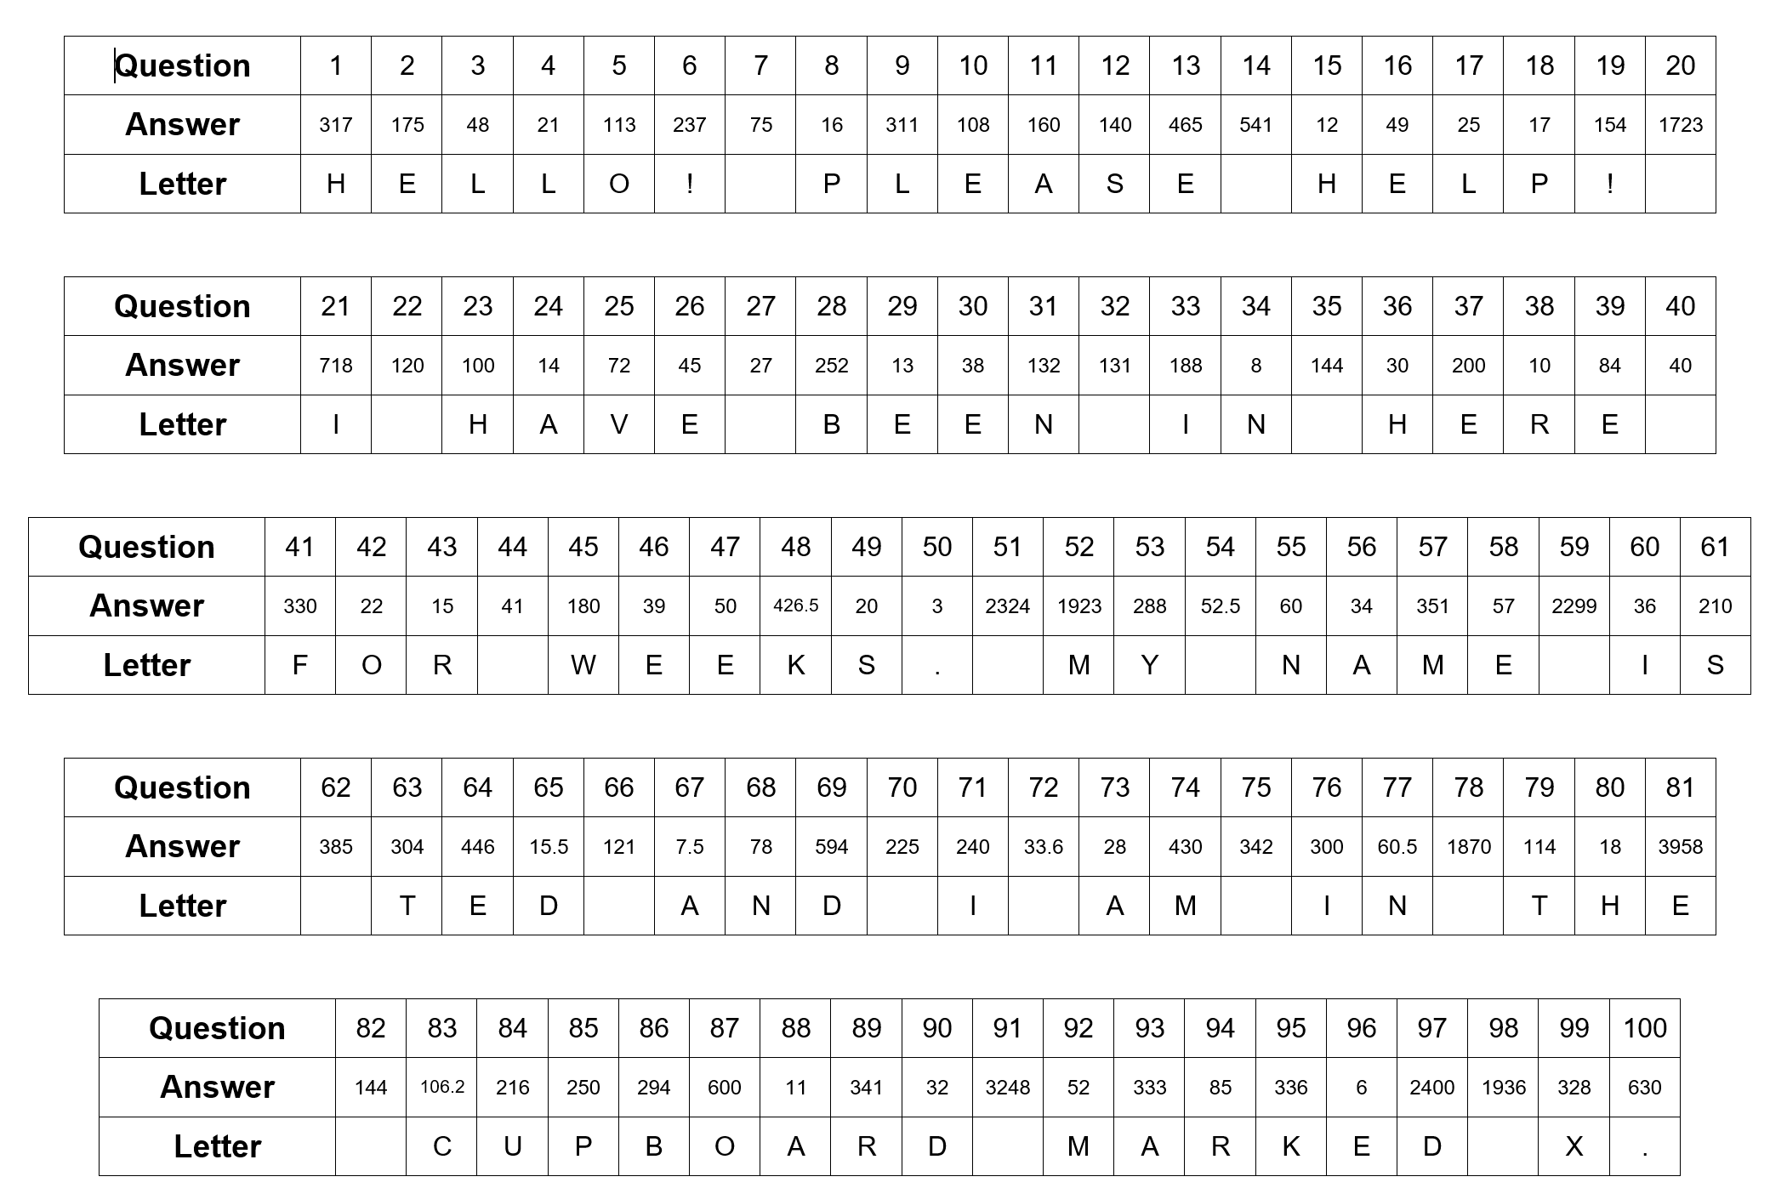
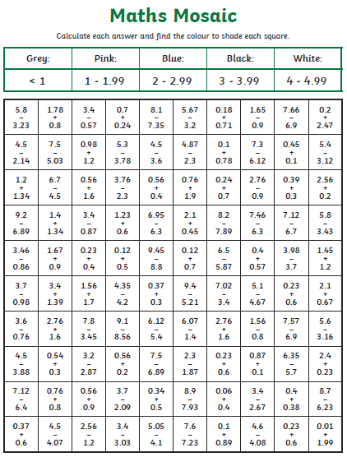

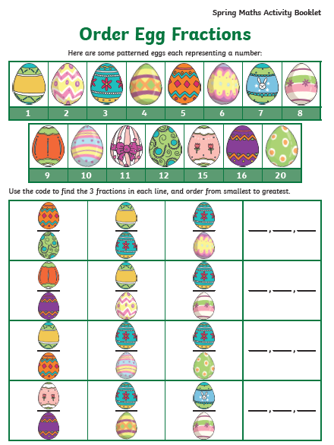
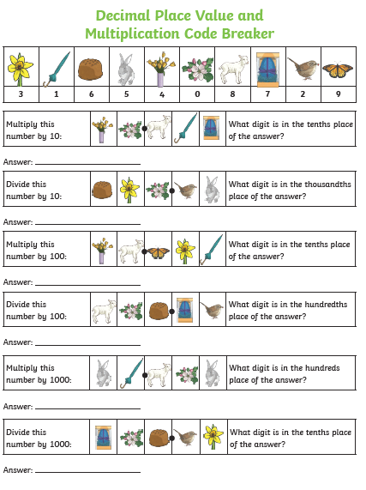
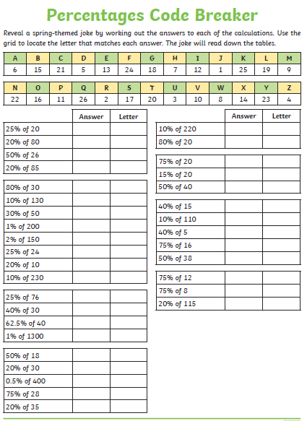

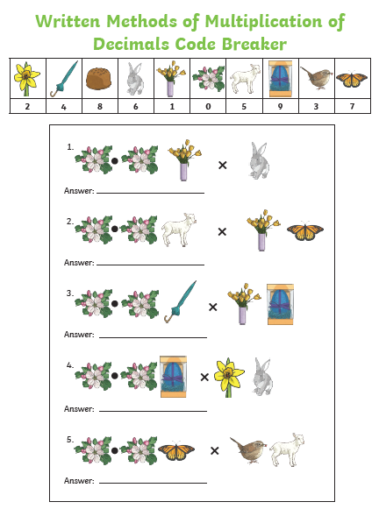
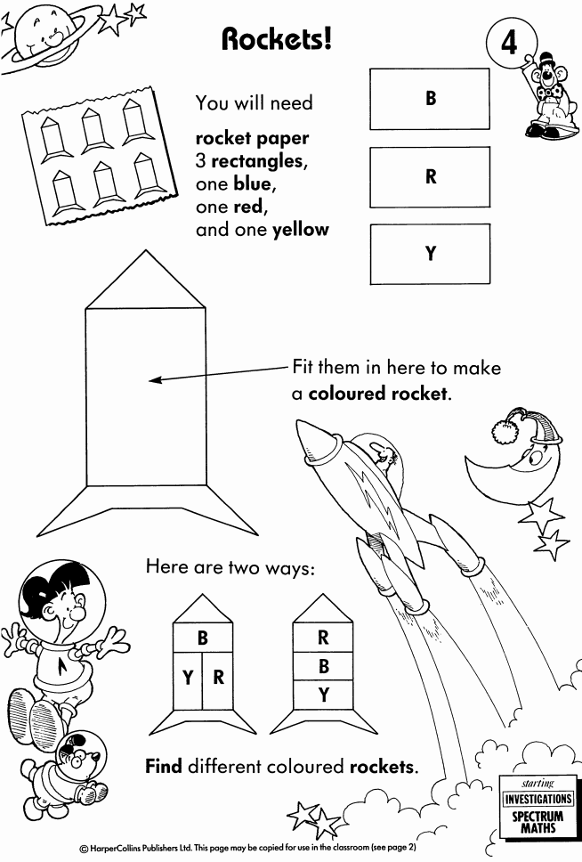

Rockets! – teacher notes
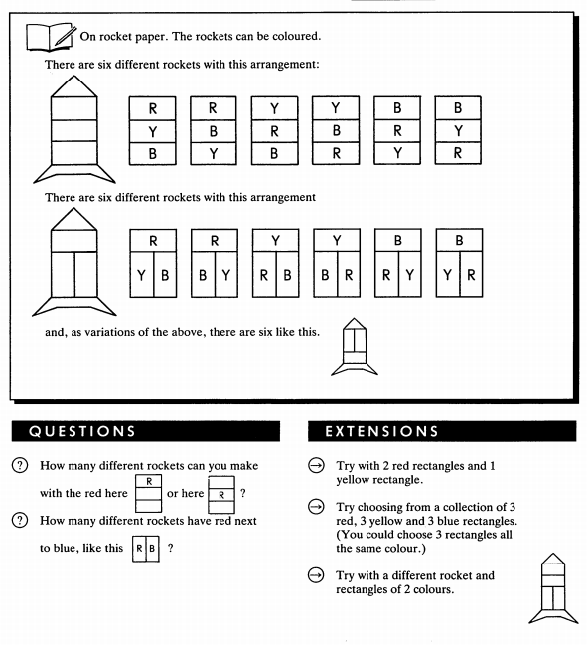

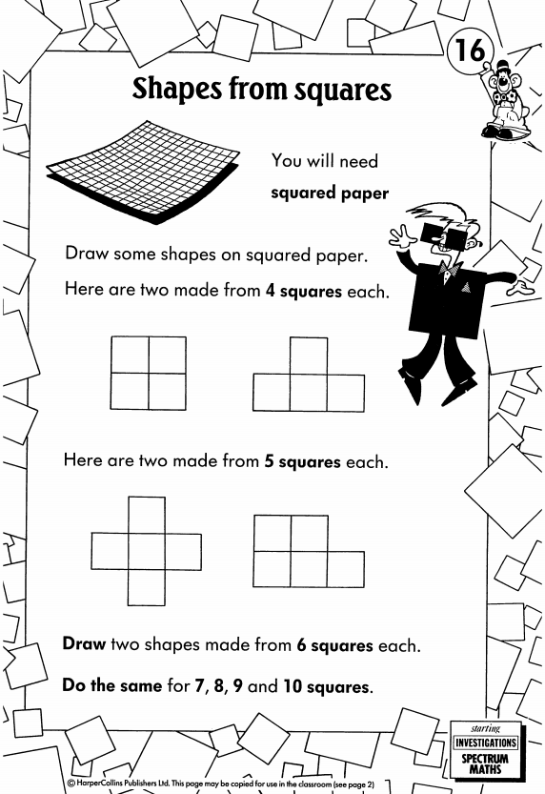

Now find every possible shape you can make from 5, 6, 7 and 8 squares.
Shapes from Squares – notes for teachers

