5 easy art activities that need no expertise and no specialist equipment!

Taking Wax Rubbings

A rubbing is something that records different textures and marks on paper. It’s really easy! You need paper and a crayon without any paper on it.
- Find a tree or any rough surface outside.
- Put your piece of paper on the surface.
- Use the side of the crayon to rub over the paper, backwards and forwards
- You should see the pattern of the surface appear on your paper
Go outside and find 6 different surfaces. You may want to take each rubbing with a different colour.

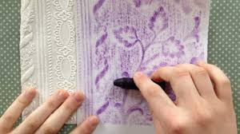

Now you’ve got the hang of it, you might want to collect six leaves from outside. Leaves that have a rough texture are best.
- Stick your leaves on a piece of paper – think carefully about how you arrange them. Stick to smoothest side downwards
- Now put another piece of paper over the top and take your rubbing
- Use different colours to make it interesting

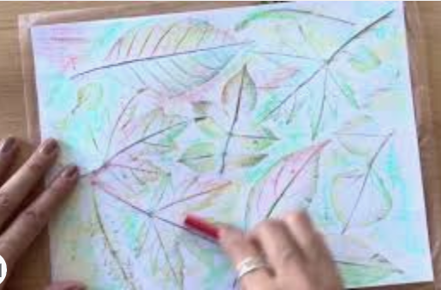

If you are feeling really creative, make a pattern with string on a piece of paper. Stick it down using glue or blue tac and take a rubbing of this.

Making wall paper
William Morris was a famous artist. Lots of his art is on wallpaper. This is because he made patterns that repeated well. Today, you are going to design a pattern that can be repeated. We are going to make a tile that we can paint and use over and over again.
- In the square below design a simple pattern using lines, shapes and swirls.

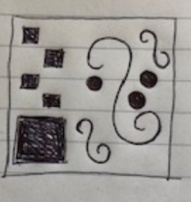

- Your teacher will give you a piece of card about the same size as your design.
- Using thick card (from a cardboard box), string and other objects that are the same sort of height copy your design so you have a tile.
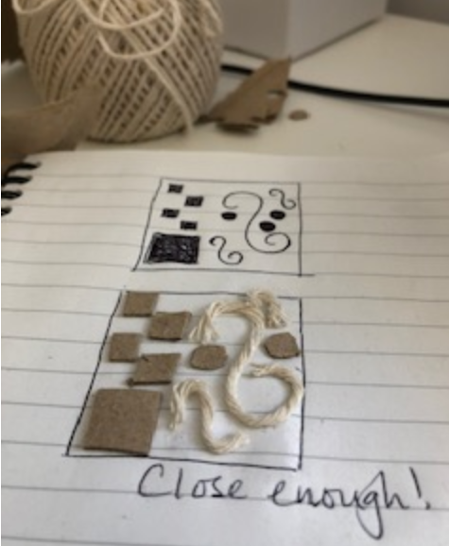
- Now using paint that is quite thick, paint the string and cardboard parts
- Turn your tile over, and print
- Try and put your prints close together so they make a repeating pattern.
- You could make a second tile and alternate your repeating pattern.
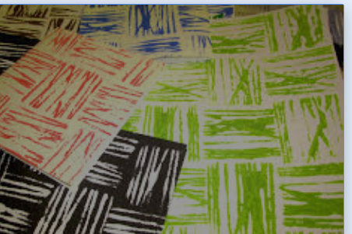

Dotty Painting!
A famous artist called George Seurat made his paintings with lots of dots. Two of his paintings are below.
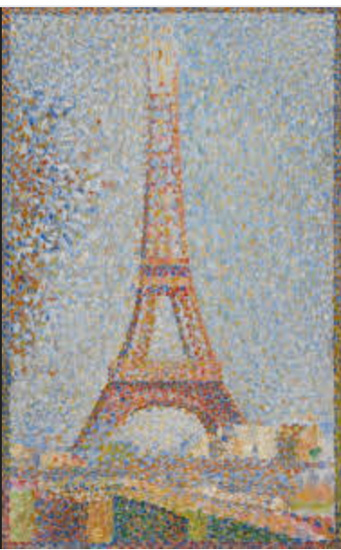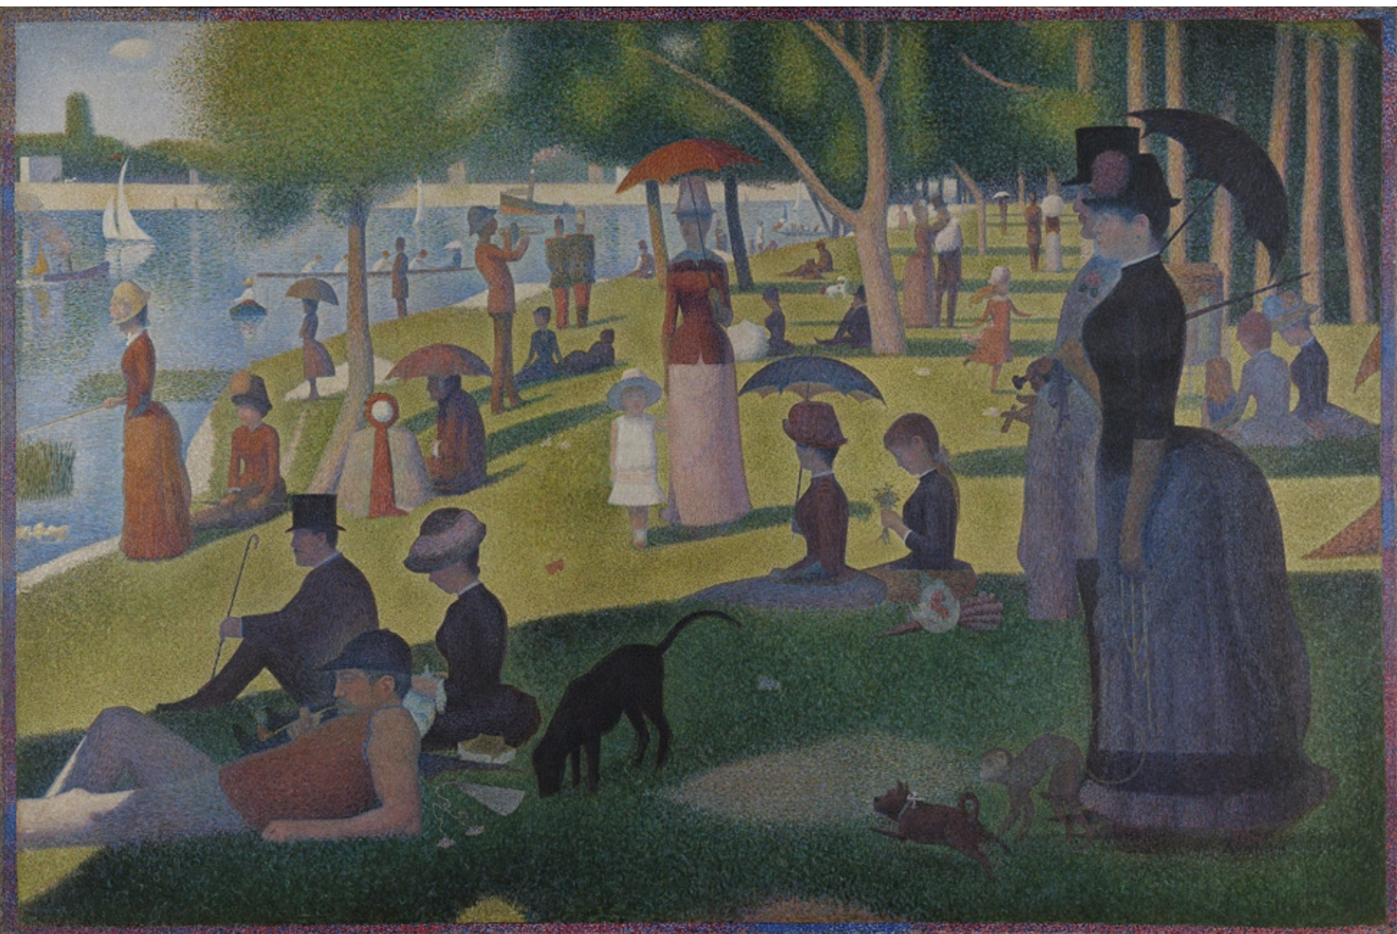

Today you are going to paint using dots.
First you need to find some things that would make a dot. This could be a large dot with the end of a pencil, a small dot with a cocktail stick or anything in between. You might decide you want to use even bigger dots and use your finger instead.

Decide what you want to paint, then get dotty. It will work best with poster paint, but you could use watercolour for fingers.
You only need to dip the very end of you painting tool into the paint.
Here are some ideas below if you can’t decide what to paint.

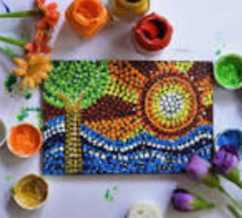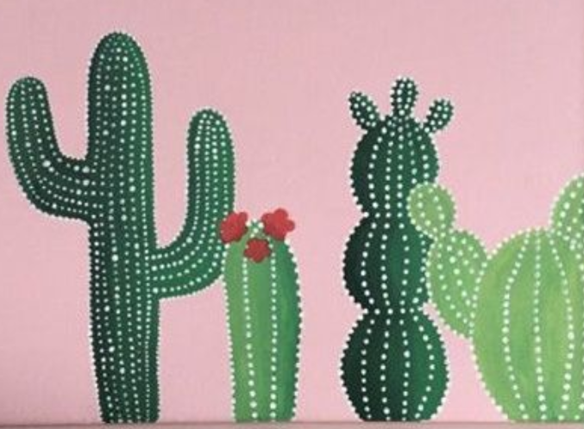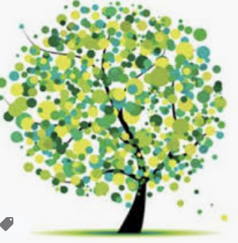
Sea and sun cactus tree or flowers

Scratch art
Today we are going to make art by scratching off paint to show colours underneath.
Your teacher might show you this video so you know what you are doing
https://www.youtube.com/watch?v=PQ6urjoVZkY
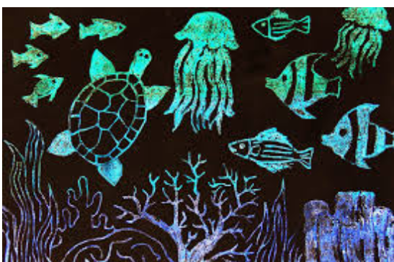

We are going to create imaginary tropical fish!
- Using wax crayons, completely colour a page with different colours all over. It can be a pattern or totally random! Make the crayon thick.
- Now using quite thick blue or black paint, paint over the crayon so the whole page is blue.
- Now the paint needs to dry, so your teacher might take you out for break or show you a film clip
- Design some beautiful or weird tropical fish
- When the paint is dry, find something to use to scratch it off. Scissors or hard plastic work well. A biro shell without the ink/pen bit in works well too. A cocktail stick does the trick nicely.
- Using your designs, see if you can create a tropical underwater scene by scratching off the paint

Adult – links to aquarium and nemo clips for drying time
Nemo 14 mins clip of best bits https://www.youtube.com/watch?v=51qdaXZS9Jk
Ten most colourful freshwater fish, 5 mins https://www.youtube.com/watch?v=U9uxHz6MWCs

Painting like Kadinsky

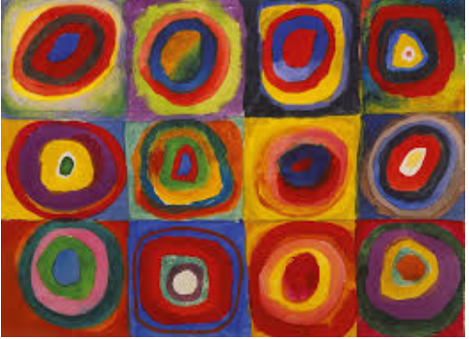
The artist Kadinsky painted using repeating ideas in boxes, but using different colours. He makes his shapes get smaller within each other. Today you are going to create your own Kadinsky style art.
- First decide on a shape you could use. If you’re not sure, try circles, triangles or a heart.
- Split your page into 12 boxes, or use the sheet on the next page as your template.
- Decide on six colours you are going to use. A mix of bright colours might look best.
- Draw the same shape design in each box, then get colouring or painting.

Here are a couple of designs you could try
