5 easy Art activities
(Unit 2)

Roman Art
Romans used little ceramic and glass tiles to make pictures on floors and walls. These are called mosaics. Here are some examples.
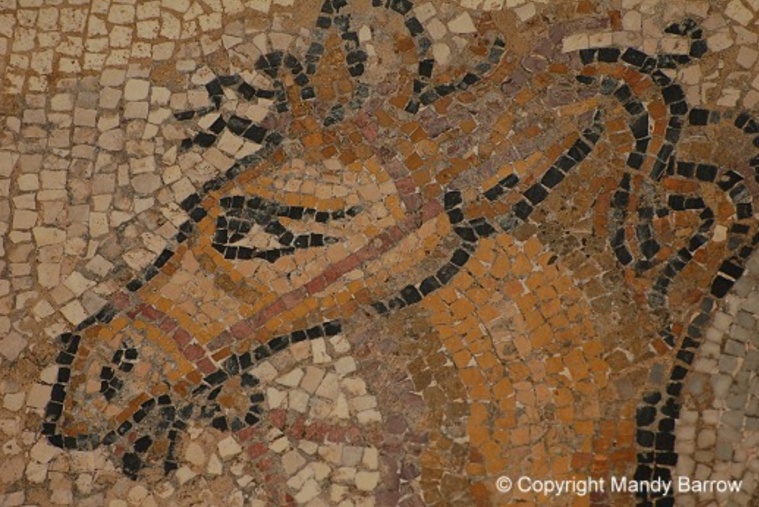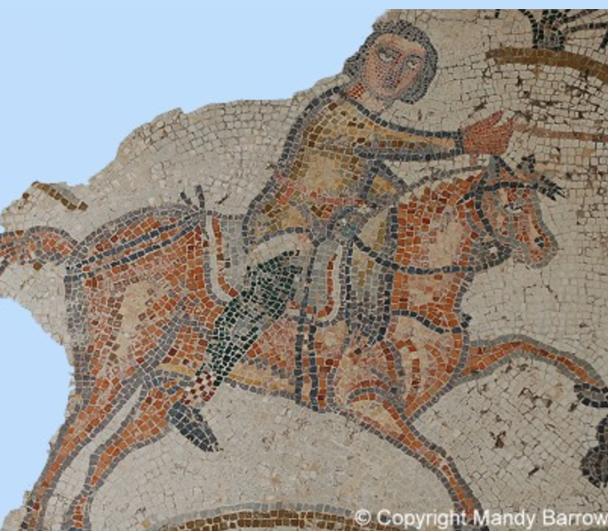
Today, you are going to make your own mosaic by cutting little tiles out of card, then sticking them to make a picture.
You can make your own design or you can use the picture below.

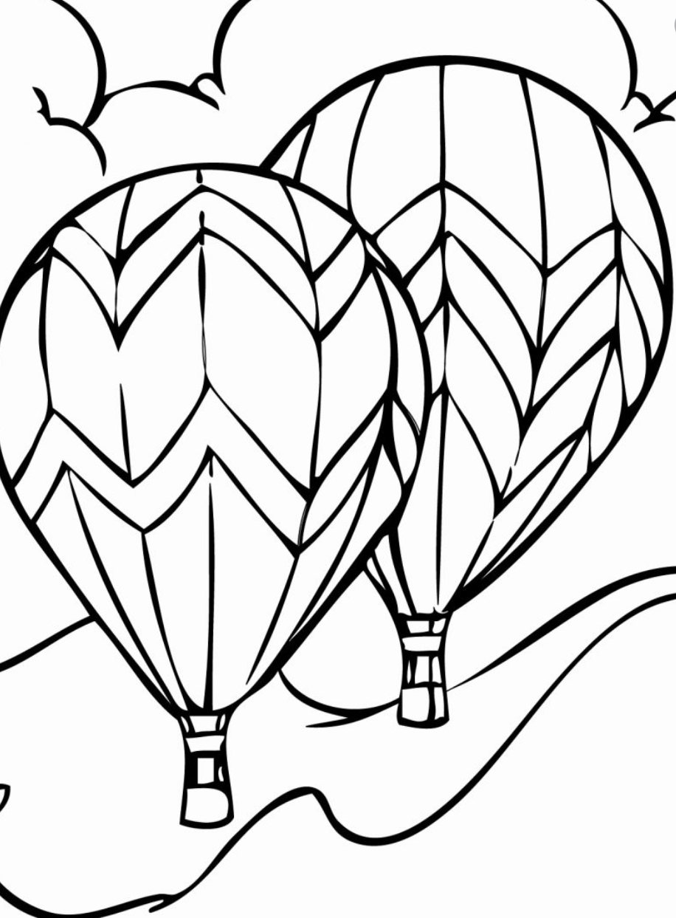
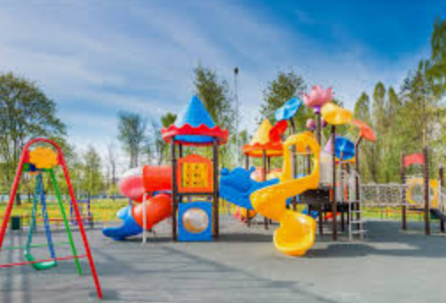
The best play park ever!
Unfortunately, we aren’t allowed to go to the playground at the moment, so instead let’s design our own!
What do you like best about going to the park or playground?
What things do you wish parks or playgrounds had that they don’t?
If you could design a new piece of equipment, what would it look like? Draw a sketch of it below.

Now draw a map of what your playground would look like if you were the designer.

Pastel art
Today we are going to use pastels and chalks to make images. Once, you got the hang of it, you can be as creative as you like to make an amazing image.
- Collect some interesting shaped leaves – bigger ones are better
- Now stick a leaf on some black or dark coloured paper with a few little bits of blue tac. (You need to be able to peel the leaf off at the end).
- Use pastels or chalks to make swift outward strokes from the leaf to the paper. Or colour round the leaf in a thick band and use your finger to do swishing outward strokes, like in the picture below.
- Once you’ve done one leaf you could add other leaves to the picture. Or you could draw your own idea onto a piece of card, cut it out and use it instead of a leaf.

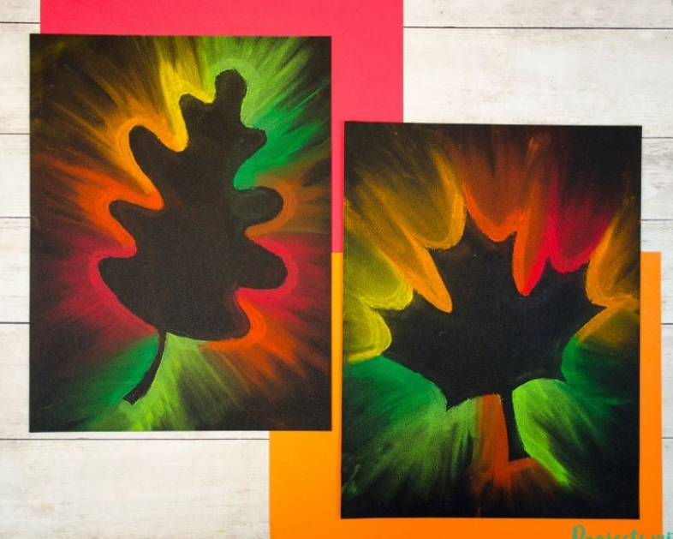

Easter Egg Designs
How many Easter egg packaging designs can you come up with? Try and create patterns that are as detailed and awesome as possible. Here are some great patterns to get you thinking.

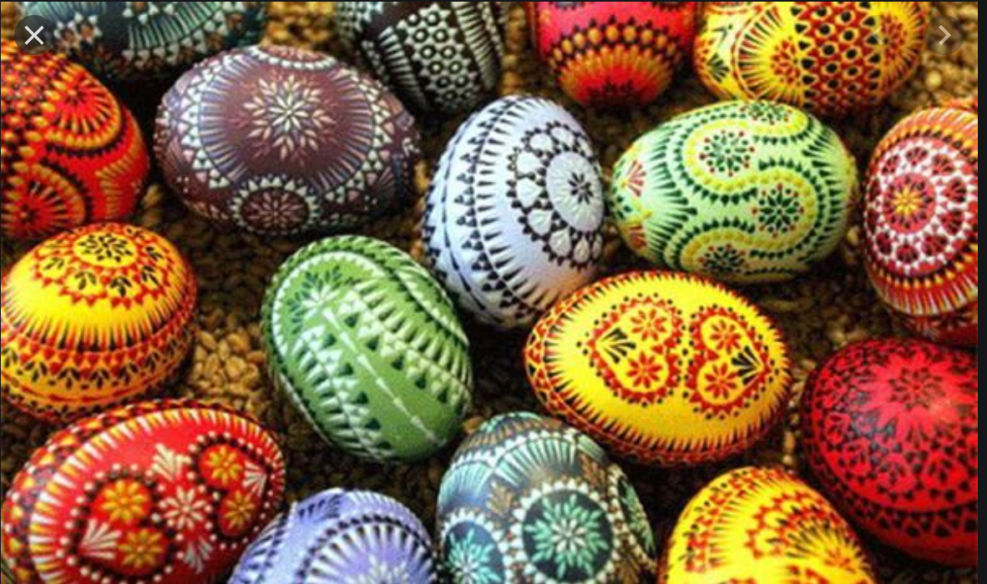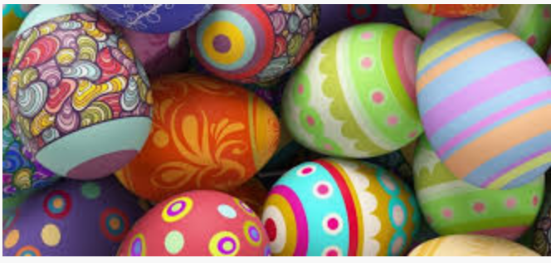

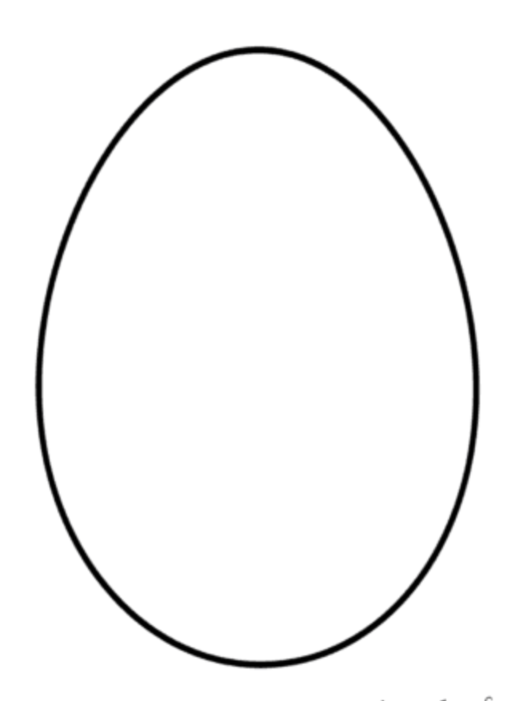

Hidden treasure
Some people have been painting rocks to hide all over the country for children to find and re-hide in different places.
Today we are going to paint as many stones and rocks as we can to hide around our school grounds for people to find when we are all back together.
Remember to put your first name on the back so the finder knows who the artist is. Also remember not to tell any children who aren’t here so it’s a big surprise when they are back.
You can paint anything you like on your stone. Your teacher might get you to paint PVA glue over your design once your stone is dry so it can’t get washed off in the rain. If your school have acrylic paints, this will help too. If you haven’t got any paint, coloured pencils or sharpies work just as well.

