PSHE/WELLBEING Activities with LITERACY Links
- Mindfulness: Signs of Spring
If you can, go outside for this. What can you see, what can you hear, what can you feel?
Draw the things that come to mind. Make a collage/mind-map of the things that come to mind.
Back in class, write a poem (SPRING acrostic/ The Joys of Spring – In Spring I hear… In Spring I see… In Spring I feel… In Spring I think about... In Spring I can smell… etc…)
You could write a short Spring setting description in a forest, by a lake, on a mountain.
At a later date, you might want to do a relaxation/meditation activity. Ask the children to lie down, close their eyes and imagine they are in a place in Spring setting; what can they hear, see, smell, touch. How does it make them feel? What questions have they? What are they grateful for? What makes you feel good?
- Mood painting:
Talk about how different colours represent feelings. Then ask children to produce a mood painting to reflect the way they feel at the time or produce a wave of changing colour across the page to represent how they have been feeling over the course of a week.
Having produced it in colour, it is easier to talk about or they can write a diary entry for how they feel (or felt at a time in the week) and explaining their choice of colour.
- It’s okay to feel worried so long as we share them:
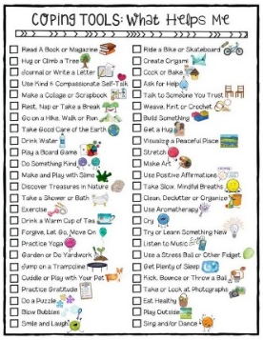
Make a list of things that worry us and a list of things that make us happy/smile.
Click on the image and enlarge it to see it in more detail.
Consider who can help us and who we can share our worries with.
Using the picture below make a first aid box for your worries. Write your worries down on coloured paper eg blue (or get someone to write them for you) and stick them to the box, or write them using a coloured pencil.
Think about things that help to ease your worries – what makes you feel better? What makes you smile? What makes you feel safe? Write these on different coloured paper eg yellow and stick them around the box, or write them around the box using a different colour.
Look at each of the worries in your box. Which of the yellow strategies could you use to help manage your worries? Are there any worries left? Talk to a friend or an adult about what might else you could do.
You can use a real box with things in it that make you smile or little notes that suggest what you can do if you are worried.
FIRST AID KIT WORKSHEET:

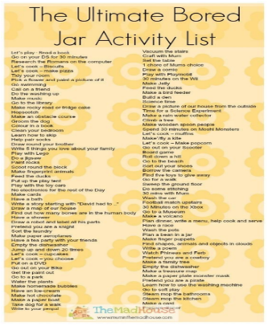
- I’ll never be bored again!
Kids at home might be a little bit bored and mums and dads might be struggling to think of things to do with their children. Can you make a list of things to do? Maybe publish the children’s list on your school website for parents to see.

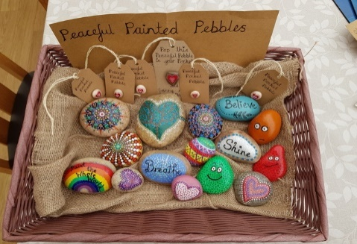
- Gratitude Stones/Message Stones:
Click on the image and enlarge it to see it in more detail
Using some flat stones or pebbles, paint a picture on one side and write something you are grateful for/a positive message on the other side.

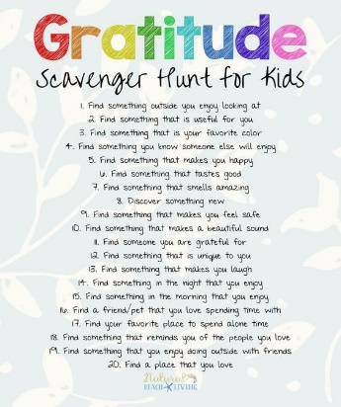
- Gratitude Scavenger hunt:
We all need to be grateful for what we have at the moment, so this activity encourages us to reflect on what we can be grateful for in our lives.
Once you have tried this, see if you can add some other things to find which also encourage us to recognise and reflect on the good things in our lives.
Swap with a partner to try out each others.
Once you have done the scavenger hunt, choose ten of the things you found and them into a poem….
Click on the image and enlarge it to see it in more detail
I am thankful for…… because…..

- Hygiene: How often?
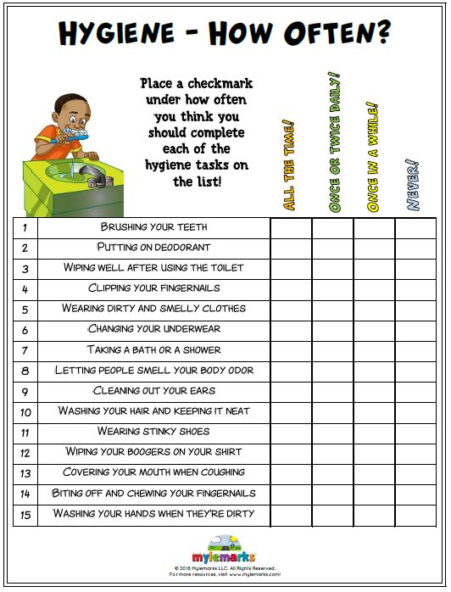
Good hygiene has never been more important so why not look at our hygiene practices a little more widely and see where we can improve.
Copy and paste this image to use it as a worksheet for reflecting on our hygiene practices.
Afterwards you might want to write a set of instruction for:
- How to Wash Your Hands properly
- Steps to avoid spreading Corona Virus
- How to be more hygienic
- How to keep yourself and others safe

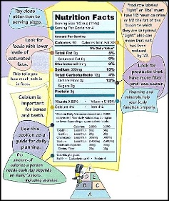
- Beating the Bugs: Healthy Eating
Eating healthily and building up a strong immune system is really important right now. Here are some activities children could do to better understand how they can do this.
- Group healthy foods into different categories and learn about what they do for us.
- Complete a Nutrition Label Scavenger Hunt.
- Research different Vitamins, where we can get them from and the benefits of them.
- Plan a Healthy Menu
- Survey the class to see who regularly eats different healthy foods/super foods and graph the results.
- Research the foods that strengthen our immune system.
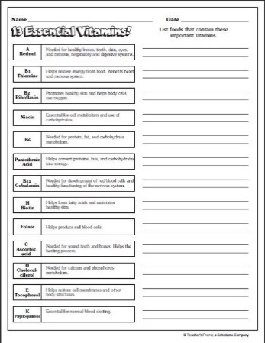
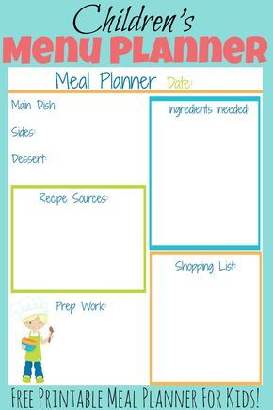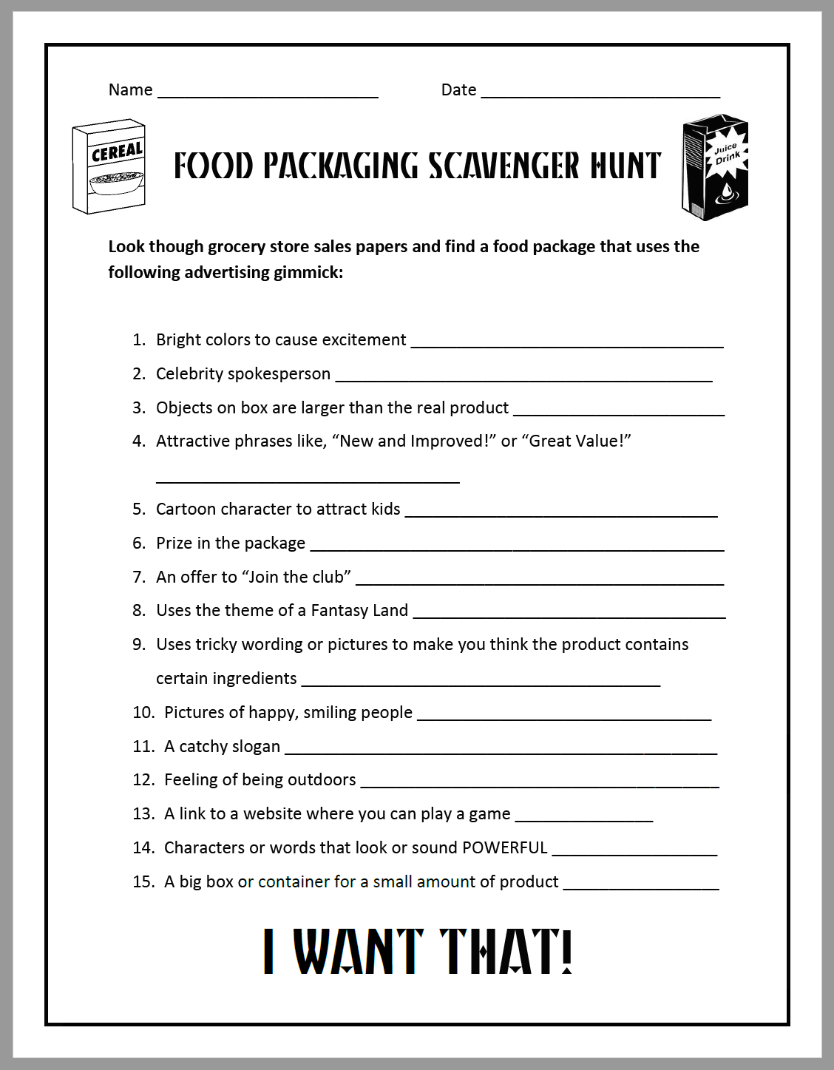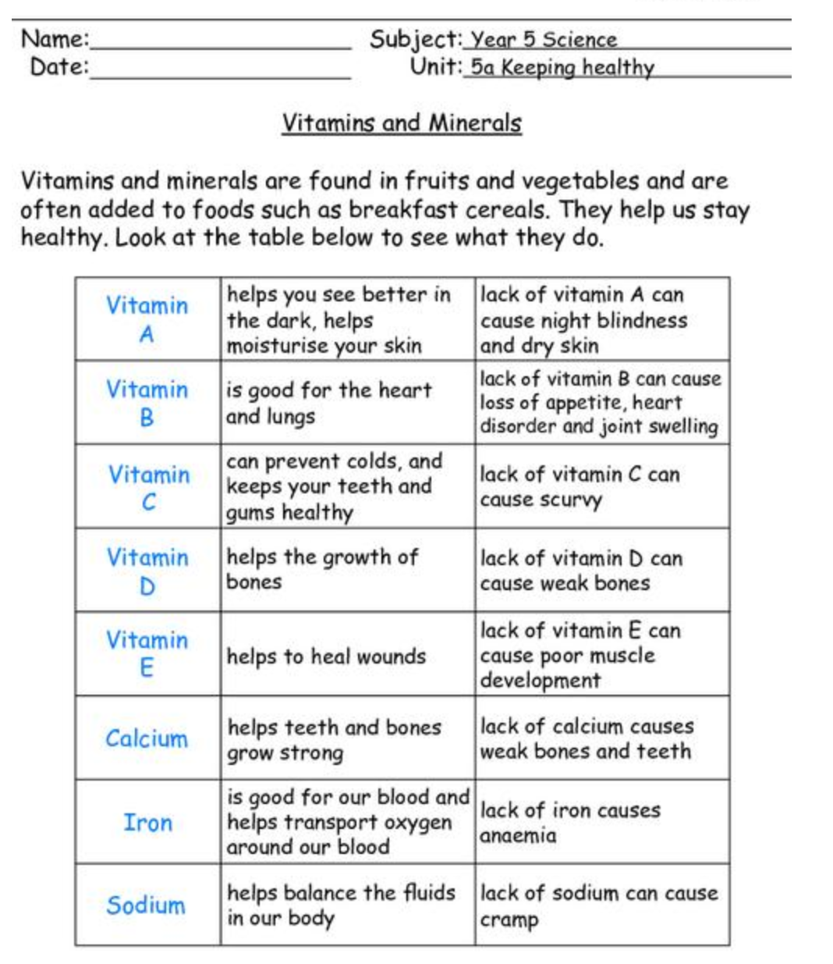

- Managing Screen-time
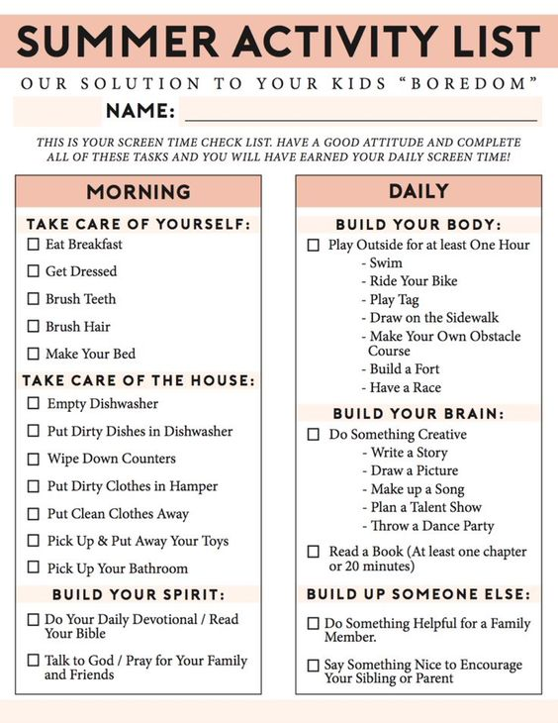
Now that children are not in school, the temptation to spend more time on devices and screens is even greater.
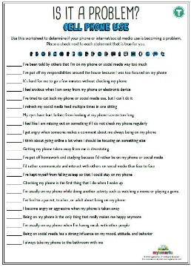
- Why not have a discussion about the effects of too much screen time.
- Then we could make a poster that warns of the dangers of too much screen time.
- Maybe make a list of things that we must have done before we ask to have screen-time.
- Perhaps prepare a debate for/against limiting screen time.

- Share a story with a PHSE/WELLBEING theme and discuss it together.
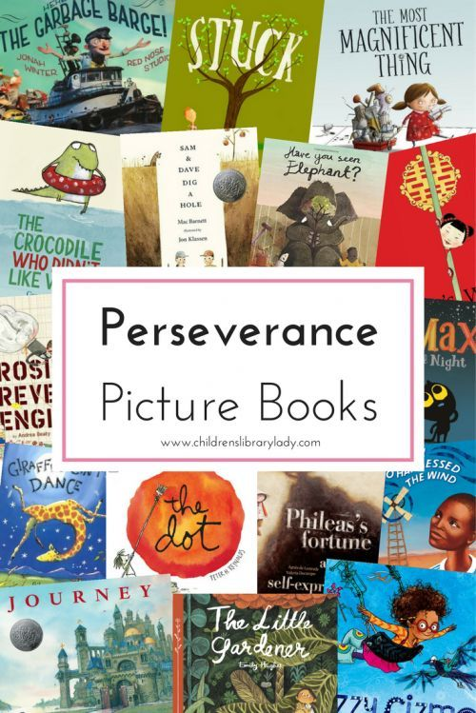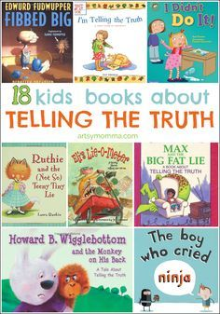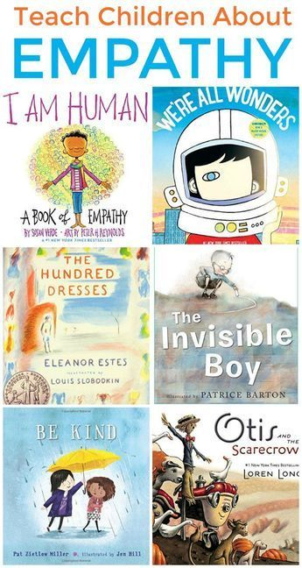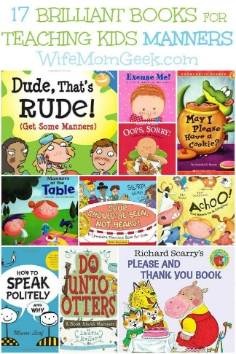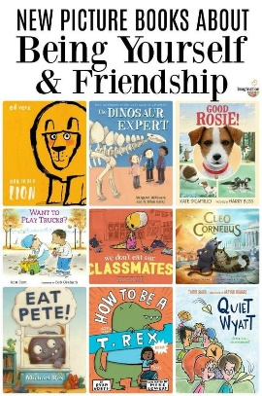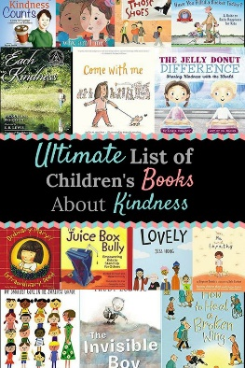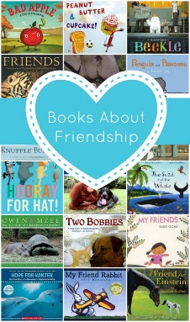
Click on the book collection and enlarge it to see it in more detail.

`

