10 Musical Games
Clapping Games
‘Don’t Clap This One Back’
Adult claps a rhythm and the children (in unison or individually) copy the rhythm. If the teacher plays the agreed ‘forbidden rhythm’ however, the children must not copy the adult.
‘Two in a Row’
Adult claps a rhythm. The children copy. This continues until the teacher claps the same rhythm twice in succession. Can the children spot repeated rhythmic phrases and not copy the adult when these occur.
‘send out a rhythm’
Adult claps a steady pulse. Nod to a child to send out a rhythm and pass it around the circle other children try and clap the steady pulse until the rhythm reaches them.
‘Follow the conductor’
Adult conducts four beats (down, right, left, up) and matches 1,2,3 and 4 to the actions. Say a number (1,2,3 or 4) children clap on the right beat. Choose a child to conduct – can everyone clap on the right beat?
‘Miss the beat’
Clap four steady beats – can you miss four, then 3, then 2 and then 1?
‘Rhythm patterns’
How many clapping patterns can you make from a crotchet, two quavers and a minim? Which other combinations can you make?
‘Sevens’
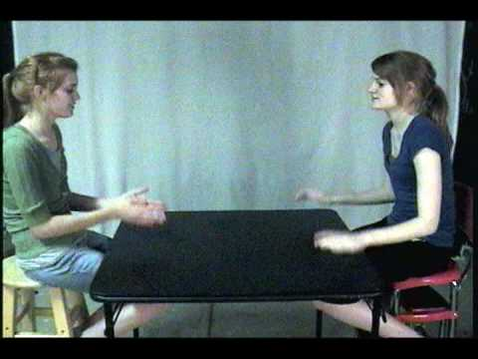

Singing and warm up games
‘In a round’
All of these can be sung in a round up to four parts. When they have mastered these can they make their own lyrics up for each melody?
Row, row, row your boat
Gently down the stream
Merrily, merrily, merrily, merrily
Life is but a dream
London’s burning, London’s burning
Fetch the engine, fetch the engine
Fire Fire! Fire Fire!
Pour on water, pour on water
Three blind mice, three blind mice
See how they run, see how they run
They all ran after the farmer’s wife
Who cut off their tails with a carving knife
Have you ever seen such a sight in your life
As three blind mice
‘Sing my name’

Do As I Say, Not As I Do
The title of this game says it all! Give an instruction to the group whilst doing something different yourself e.g. say ‘hands on your head’ while you put your hands on your shoulders, or say ‘hands on your knees’ while putting your hands on your head. The children should do the verbal instruction rather than trying to copy your movements. No cheating by closing eyes or looking away!
Extension:
Try changing the rules. For example, you could ask them to do as you did, not as you do i.e. without any verbal instructions, tap your head twice, then your shoulders twice, then your knees twice etc in rhythm. The children should copy you, but 2 beats behind, so that they’re always doing what you just did.

