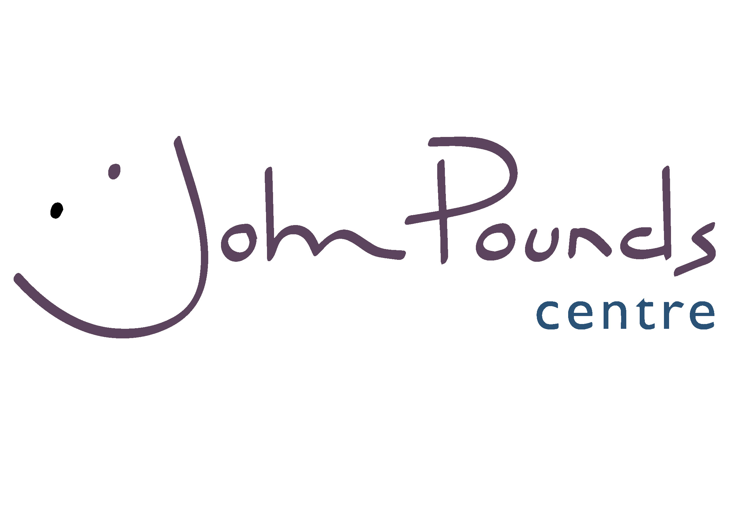



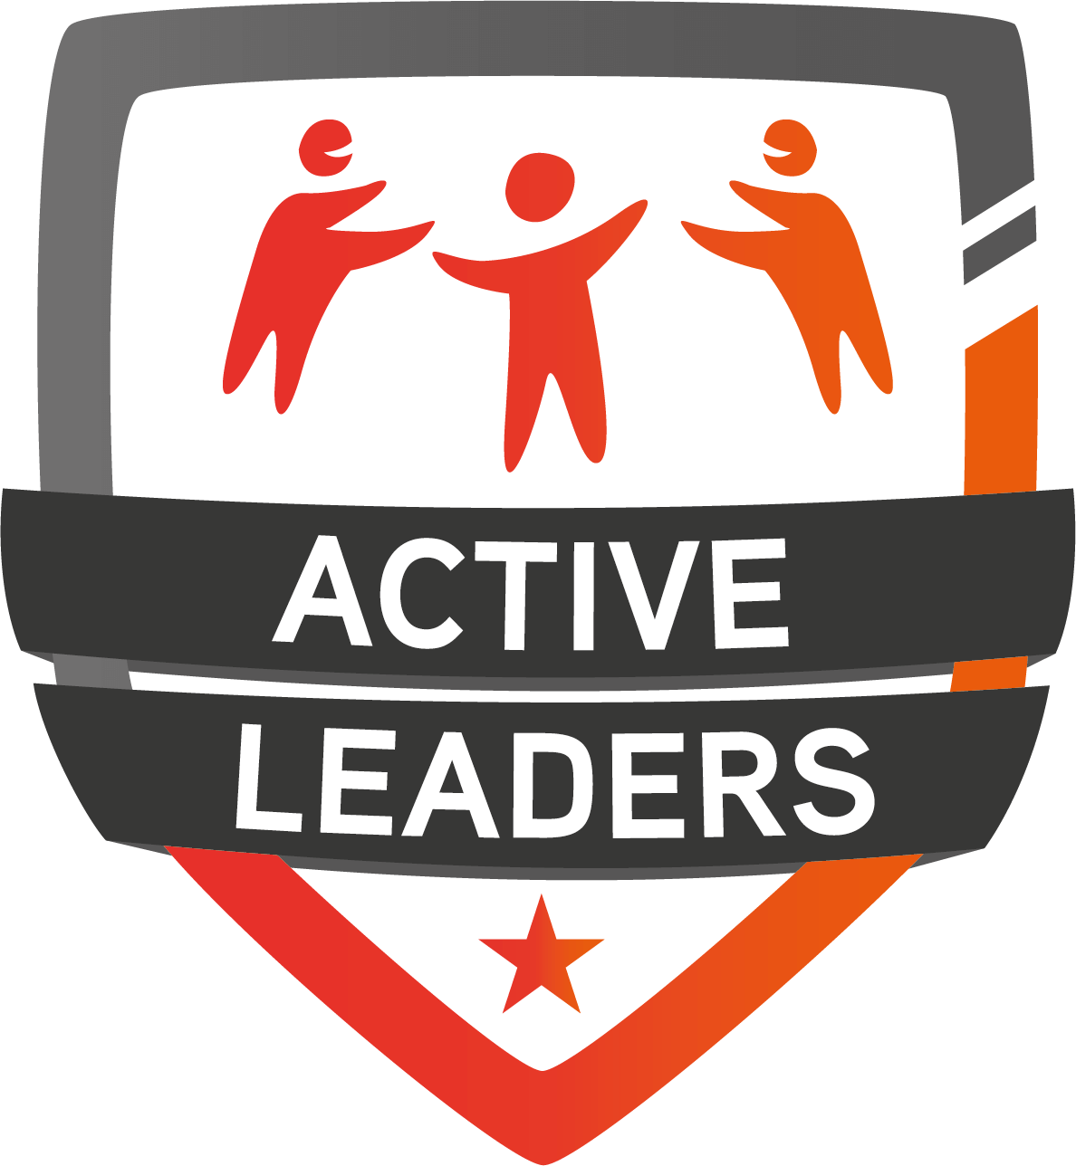

February Half Term Activity Week 2019

### PARENTAL CONSENT FORM

|  |  |  |  |  |
| --- | --- | --- | --- | --- |
| Name of Camp | **Active Leaders Camp** | | Dates | **Monday 18th – Friday 22nd February** |
|  |  |  |  |  |

|  |  |  |  |  |  |  |  |  |  |  |  |  |  |  |  |  |  |  |  |  |  |  |  |  |  |  |  |  |  |  |  |  |  |  |  |  |  |  |
| --- | --- | --- | --- | --- | --- | --- | --- | --- | --- | --- | --- | --- | --- | --- | --- | --- | --- | --- | --- | --- | --- | --- | --- | --- | --- | --- | --- | --- | --- | --- | --- | --- | --- | --- | --- | --- | --- | --- |
| Name of Child | | | | |  | | | | | | | | | | | | | | | | | | Date of Birth | | | | | | |  | | | | | | | | |
|  | | | | | | | | | | | | | | | | | | | | | | | | | | | | | | | | | | | | | | |
| Address | | | |  | | | | | | | | | | | | | | | | | | | | | | | | | | | | | | | | | | |
|  | | | | | | | | | | | | | | | | | | | | | | | | | | | | | | | | | | | | | | |
|  | | | | | | | | | | | | | | | | | | | | | | | | | | | | | | | | | | | | | | |
|  | | | | | | | | | | | | | | | | | | | | | | | | | | | | | | | | | | | | | | |
| Male | |  | | | |  | | | | Female | | | | | |  | | | |  | Child’s School | | | | | | | | |  | | | | | | | | |
|  | | | | | | | | | | | | | | | | | | | | | | | | | | | | | | | | | | | | | | |
| Emergency contact numbers | | | | | | | | | | | | | | |  | | |  | | | | | | | | |  | |  | | | | |  | | | | |
|  | | | | |  | | |  | | | | | | | 1. |  | | | | | | | | | | | | Contact | | | | |  | | | | | |
|  | | | | | | | | | | | | | | | | | | | | | | | | | | | | | | | | | | | | | | |
|  | | | | |  | | |  | | | | | | | 2. |  | | | | | | | | | | | | Contact | | | | |  | | | | | |
|  | | | | | | | | | | | | | | | | | | | | | | | | | | | | | | | | | | | | | | |
| Parents Email Address | | | | | | | | | | |  | | | | | | | | | | | | | | | | | | | | | | | | | | | |
|  | | | | | | | | | | | | | | | | | | | | | | | | | | | | | | | | | | | | | | |
| Has your child been on any long or short-term medication in the last six months? | | | | | | | | | | | | | | | | | | | | | | | | | | | | | | | | | | | | | YES / NO | |
|  | | | | | | | | | | | | | | | | | | | | | | | | | | | | | | | | | | | | | | |
| If Yes, please give details: | | | | | | | | | | | |  | | | | | | | | | | | | | | | | | | | | | | | | | | |
|  | | | | | | | | | | | | | | | | | | | | | | | | | | | | | | | | | | | | | | |
|  | | | | | | | | | | | | | | | | | | | | | | | | | | | | | | | | | | | | | | |
|  | | | | | | | | | | | | | | | | | | | | | | | | | | | | | | | | | | | | | | |
| Has your child ever suffered from any of the following? | | | | | | | | | | | | | | | | | | | | | | | | | | | | | | | | | | | | | | |
|  | | | | | | | | | | | | | | | | | | | | | | | | | | | | | | | | | | | | | | |
| a) Chest Pains | | | | | | | | | YES / NO | | | | | | | | | b) Joint Problems | | | | | | | | | | | | | | | | | YES / NO | | | |
|  | | | | | | | | | | | | | | | | | | | | | | | | | | | | | | | | | | | | | | |
| c) Lower Back Pains | | | | | | | | | YES / NO | | | | | | | | | d) Heart Problems | | | | | | | | | | | | | | | | | YES / NO | | | |
|  | | | | | | | | | | | | | | | | | | | | | | | | | | | | | | | | | | | | | | |
| e) Asthma | | | | | | | | | YES / NO | | | | | | | | | | f) Severe headaches or dizziness | | | | | | | | | | | | | | | | YES / NO | | | |
|  | | | | | | | | | | | | | | | | | | | | | | | | | | | | | | | | | | | | | | |
| g) Diabetes | | | | | | | | | YES / NO | | | | | | | | | h) Epilepsy | | | | | | | | | | | | | | | | | YES / NO | | | |
|  | | | | | | | | | | | | | | | | | | | | | | | | | | | | | | | | | | | | | | |
| i) Or any other relevant condition we should be aware of? | | | | | | | | | | | | | | | | | | | | | | | | | | | | | | | | | | | YES / NO | | | |
|  | | | | | | | | | | | | | | | | | | | | | | | | | | | | | | | | | | | | | | |
| If yes, please state current treatment and medication | | | | | | | | | | | | | | | | | | | | | | | |  | | | | | | | | | | | | | | |
|  | | | | | | | | | | | | | | | | | | | | | | | | | | | | | | | | | | | | | | |
|  | | | | | | | | | | | | | | | | | | | | | | | | | | | | | | | | | | | | | | |
|  | | | | | | | | | | | | | | | | | | | | | | | | | | | | | | | | | | | | | | |
|  | | | | | | | | | | | | | | | | | | | | | | | | | | | | | | | | | | | | | | |
|  | | | | | | | | | | | | | | | | | | | | | | | | | | | | | | | | | | | | | | |
| Has your doctor ever advised your child not to exercise? | | | | | | | | | | | | | | | | | | | | | | | | | | | | | | | | | | | YES / NO | | | |
|  | | | | | | | | | | | | | | | | | | | | | | | | | | | | | | | | | | | | | | |
| If YES, please give details | | | | | | | | | | | |  | | | | | | | | | | | | | | | | | | | | | | | | | | |
|  | | | | | | | | | | | | | | | | | | | | | | | | | | | | | | | | | | | | | | |
|  | | | | | | | | | | | | | | | | | | | | | | | | | | | | | | | | | | | | | | |
|  | | | | | | | | | | | | | | | | | | | | | | | | | | | | | | | | | | | | | | |
|  | | | | | | | | | | | | | | | | | | | | | | | | | | | | | | | | | | | | | | |
|  | | | | | | | | | | | | | | | | | | | | | | | | | | | | | | | | | | | | | | |
|  | | | | | | | | | | | | | | | | | | | | | | | | | | | | | | | | | | | | | | |
|  | | | | | | | | | | | | | | | | | | | | | | | | | | | | | | | | | | | | | | |
| Doctor’s name and surgery: | | | | | | | | | | | | | |  | | | | | | | | | | | | | | | | | | | | | | | | |
|  | | | | | | | | | | | | | | | | | | | | | | | | | | | | | | | | | | | | | | |
|  | | | | | | | | | | | | | | | | | | | | | | Telephone Number | | | | | | | | | |  | | | | | | |
|  | | | | | | | | | | | | | | | | | | | | | | | | | | | | | | | | | | | | | | |
| Has your child ever been sensitive to Penicillin? | | | | | | | | | | | | | | | | | | | | | | | | | | | | | | | | | | | YES / NO | | | |
|  | | | | | | | | | | | | | | | | | | | | | | | | | | | | | | | | | | | | | | |
| Does your child have any long-term illnesses, health problem or disability that limits his / her | | | | | | | | | | | | | | | | | | | | | | | | | | | | | | | | | | | | | | |
| enjoyment / attendance of the activity: | | | | | | | | | | | | | | | | | | | | | | | | | | | | | | | | | | | | | | |
|  | | | | | | | | | | | | | | | | | | | | | | | | | | | | | | | | | | | | | | |
|  | | | | | | | | | | | | | | | | | | | | | | | | | | | | | | | | | | | | | | |
|  | | | | | | | | | | | | | | | | | | | | | | | | | | | | | | | | | | | | | | |
|  | | | | | | | | | | | | | | | | | | | | | | | | | | | | | | | | | | | | | | |
|  | | | | | | | | | | | | | | | | | | | | | | | | | | | | | | | | | | | | | | |
|  | | | | | | | | | | | | | | | | | | | | | | | | | | | | | | | | | | | | | | |
|  | | | | | | | | | | | | | | | | | | | | | | | | | | | | | | | | | | | | | | |
|  | | | | | | | | | | | | | | | | | | | | | | | | | | | | | | | | | | | | | | |
| Which ethnic group do you consider the child / young person belongs to? | | | | | | | | | | | | | | | | | | | | | | | | | | | | | | | | | | | | | | |
|  | | | | | | | | | | | | | | | | | | | | | | | | | | | | | | | | | | | | | | |
| White | | |  | | | | Mixed | | | | | |  | | | | Asian | | | | |  | | | | Black | | | | |  | | | | | other | |  |
|  | | | | | | | | | | | | | | | | | | | | | | | | | | | | | | | | | | | | | | |
|  | | | | | | | | | | | | | | | | | | | | | | | | | | | | | | | | | | | | | | |
| I agree that the child named overleaf may attend the activities indicated and I understand that he / she will be under control of the course leader. The course leader will take all reasonable care of the children they cannot necessarily be held responsible for any loss, damage or injury suffered by my child arising during or out of these activities. | | | | | | | | | | | | | | | | | | | | | | | | | | | | | | | | | | | | | | |
| I consent to any emergency treatment necessary during the scheme, I therefore, authorise the course leader to sign, on my behalf, any written form of consent required by the hospital authorities. In the case of any hospital treatment being required every attempt will be made to contact a parent / guardian / carer. | | | | | | | | | | | | | | | | | | | | | | | | | | | | | | | | | | | | | | |
|  | | | | | | | | | | | | | | | | | | | | | | | | | | | | | | | | | | | | | | |
| **CONSENT FOR TAKING IMAGES** | | | | | | | | | | | | | | | | | | | | | | | | | | | | | | | | | | | | | | |
|  | | | | | | | | | | | | | | | | | | | | | | | | | | | | | | | | | | | | | | |
| During the course, we may take pictures and video images. We would like to use these in presentations, displays or in our own booklets, newsletters or publicity.  I **do not** consent to photos and videos being taken during this camp | | | | | | | | | | | | | | | | | | | | | | | | | | | | | | | | | | | | | | |
|  | | | | | | | | | | | | | | | | | | | | | | | | | | | | | | | | | | | | | | |
| **Signature of Parent / Guardian/ Carer** | | | | | | | | | | | | | | | | | | |  | | | | | | | | | | | | | | | | | | | |
|  | | | | | | | | | | | | | | | | | | | | | | | | | | | | | | | | | | | | | | |
| **Name** |  | | | | | | | | | | | | | | | | | | | | | **Date** | | |  | | | | | | | | | | | | | |

## To reserve a place either please hand your completed Parent Form into the Priory School Reception or send via email or text before **Friday 8th February** to secure your place, or alternatively you can post your form directly to –

## **Michael Whitelock, Portsmouth School Sport Partnership, Priory School, Fawcett Road, Southsea, PO4 8RG.**

**mwhitelock@priorysouthsea.org – 07704 189077**