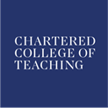

Professional Development Consortium in MFL
Using research evidence to raise attainment in the MFL classroom

Wednesday 23 May 5.00-7.00pm
St George’s Building, St Thomas’ Street, Old Portsmouth, PO1 2HY Room 1.11
Philip Campagna presents:

Developing pupil independence in the KS3 languages classroom: Skills-based teaching and learning
This workshop provides practical advice to create a classroom environment where independence, thinking skills, collaboration and active learning are developed at the same time as knowledge is acquired. This practical session examines the role of phonics, use of authentic texts, and spontaneous speaking in line with the new MFL GCSE.

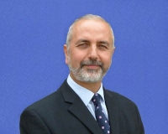

Philip is the South West Regional and also the National Director for Network for Learning. He is a Senior Lecturer and PGCE Course Leader for Secondary MFL at Bath Spa University, and is also the PGCE Primary MFL Coordinator. Philip was Head of the MFL Faculty at a large Wiltshire Community College for six years, and worked for ten years as a Primary Languages Coordinator in Wiltshire. He regularly presents for Network for Languages in the South West and in other regions. He has also presented at National and International Language Conferences.

