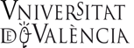 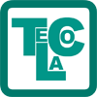 at The University of Portsmouth
presents:
The Professional Development Consortium in MFL
Using research evidence to raise attainment in the MFL classroom
Wednesday 16th January 5.00-7.00pm
St George’s Building, St Thomas’ Street, Old Portsmouth, PO1 2HY Room 0.20

The implementation of new technologies in the foreign language classroom:
the case of telecollaboration and virtual worlds

The incorporation of new technologies in classrooms has brought about a shift in teaching practices. ICTs have proven to be particularly helpful in providing opportunities for students to acquire foreign languages and to meet and talk to peers from other countries without having to leave the classroom or their homes.

In this talk we will be looking at the pedagogical affordances and constraints of telecollaboration through synchronous video conferencing and virtual worlds. We will offer practical examples of its implementation in secondary schools in several European countries: Belgium, France, Germany, Spain and the UK. We will focus especially on how a task-based approach to telecollaboration links work in the classroom with computer-based activities.

Dr. Begoña Clavel-Arroitia is a senior lecturer of English at the Universitat de València where she teaches Second Language Acquisition and Teaching English as a Foreign Language modules at both undergraduate and postgraduate level. She is a member of IULMA-UV (Interuniversity Institute of Applied Modern Languages, Universitat de València) and carries out research in the field of corpus linguistics and its applications to teaching, the implementation of ICT resources in language teaching, and the study of gender and language. She is a member of the research groups Gentext and AngloTIC. She participated in the European project TILA, Telecollaboration for Intercultural Language Acquisition, and is currently the main researcher in Spain of the European research project TeCoLa (Pedagogical differentiation through telecollaboration and gaming for intercultural and content integrated language teaching).

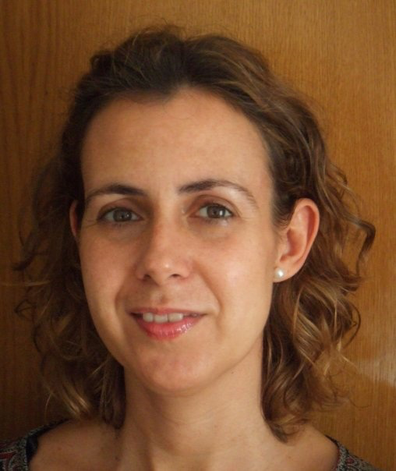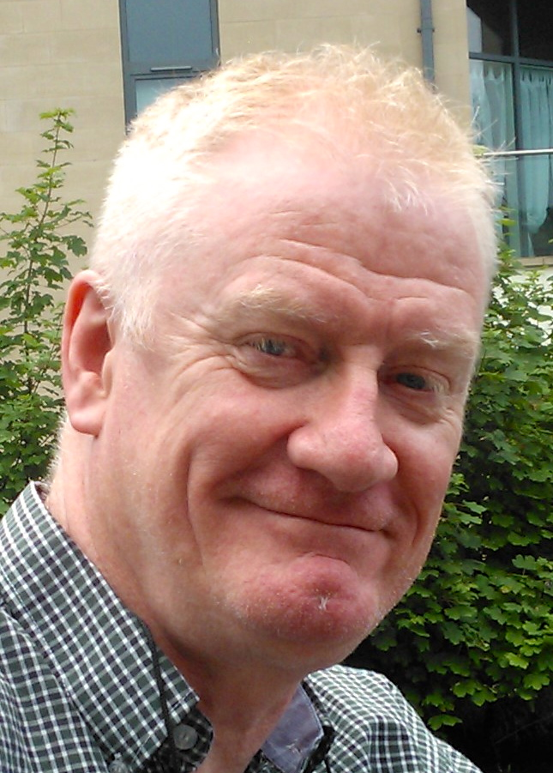

Dr. Barry Pennock-Speck is a senior lecturer at the Universitat de València and a member of IULMA- UV. The research he has carried out spans several fields: discourse analysis, ICTs and teaching, translation, phonology, pragmatics. He has published in the field of television commercials in several leading journals. He has participated in several European Projects that explore the use of ICTs for teaching. The two most recent ones are the European project: TILA, Telecollaboration for Intercultural Language Acquisition and the Erasmus+ TeCoLa project: Pedagogical Differentiation through Telecollaboration and Gaming for Intercultural and Content Integrated Language Teaching. The website he coordinates http://anglotic.blogs.uv.es/ contains a large number of learning objects. He is the author of those pertaining to the field of phonology and accents of English.

