The University of Portsmouth 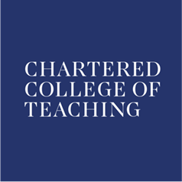 Professional Development Consortium in MFL
Using research evidence to raise attainment in the MFL classroom
Wednesday 12th December 5.00-7.00pm
St George’s Building, St Thomas’ Street, Old Portsmouth, PO1 2HY Room 1.11
Greg Horton presents:
High impact activities for engaging boys

Modern foreign languages continue to be perceived by many as a girl-friendly subject and the challenge is to lure boys away from the trap of mono-lingualism. This session will offer a range of strategies and classroom activities that have a proven track record for motivating boys through to GCSE success.

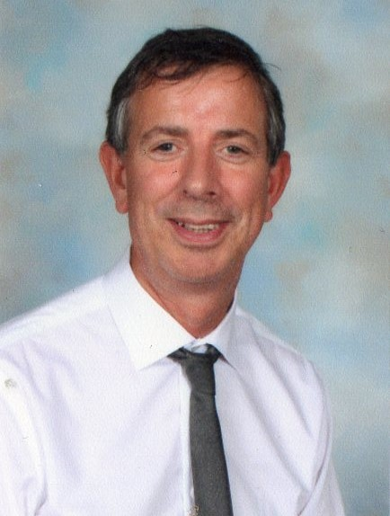

Greg Horton is an Advanced Skills Teacher with twenty-nine years of secondary classroom experience. Between 2006-2011 he worked as an SSAT Lead Practitioner. Between 2013 - 2018 he was Hampshire MFL Adviser. He also works as a senior examiner for a leading awarding body.

Greg is a regular presenter at both regional training events and national conferences. His work has gained widespread recognition and been featured on Teachers’ TV. In 2011 he was the recipient of a UK German Teacher of the Year Award.

