Primary Languages in Portsmouth
Autumn Update (September 2018)

I am pleased to inform you that we have several excellent CPD opportunities coming up for colleagues teaching a modern foreign language in both primary and secondary schools. I have attached information about these to this update.

** FREE language courses at the University of Portsmouth. The University is continuing to offer free language lessons on the Institution-Wide Languages Programme to local teachers. There is a range of languages and levels on offer but spaces are limited, so teachers need to book asap.

** Our local SLE for MFL, Marie Allen, in conjunction with the Portsmouth Teaching School Alliance, will run three days of workshops (October, February and June) on the challenges facing KS2 languages and KS2/3 transition.

** The University of Southampton is offering four days of workshops during the academic year on different aspects of teaching languages in KS2.

** The Institut Français is holding a one-day conference for teachers of French on Saturday 6 October 2018.

** The next meeting of the ALL Portsmouth Primary Hub will take place on Thursday, 18 October at Cottage Grove Primary School, Southsea. Marie Allen will share the ups and downs of planning a transition project for preparing Year Six pupils for their new language learning experience in Year Seven.

** Additionally, Tanya Riordan, the MFL PGCE course leader at the University of Portsmouth, offers a programme of relevant and innovative CPD in four sessions over the course of the academic year. Primary colleagues are very welcome to attend.

Celebrating the European Day of Languages 2018

European Day of Languages 2018: a few ideas you may find useful!
European Day of Languages takes place each year on 26 September. (but you can always choose a date around that time that’s more suitable for you)

Activities:
Council of Europe’s official European Day of Languages site: Includes quizzes, trivia, materials and games.
SCILT European Day of Languages: ideas for primary, secondary and parents and families.

Competitions:
ALLNE European Day of Languages Competition 2018: ALLNE and partners are once again organising the annual European Day of Languages Competition for Schools and in 2018 it is again open to anyone! We were delighted with response from around the country in last year’s competition (I have a dream) and look forward to the entries this year. The organising committee invites language learners in any key stage to create a piece of text in a language they are learning on the theme: European Day of Languages 2018 – A recipe (for hapiness).
The LANGUAGE MAGICIAN Singalong: A quick activity, easy to manage, for teachers and pupils in Primary schools in the UK and around the continent!

Resources:
Making the case‬: Why learn languages? Contains links to advice from people who know, and powerful reasons why learning languages equips your students with the knowledge and skills to take advantage of the opportunities of life in the 21st century – plus useful further information for students, teachers, parents and others on the importance of language skills.
Why study languages: Promoting languages in schools: Student facing website containing interactive quizzes, videos and practical advice for KS3, KS4 and Post-16; written by university students with recent experience of studying for GCSEs and A-levels.
ALL on Pinterest: Check out our extensive language collections.
Inspiring the Future: A quick and easy way for schools and employers to connect, with hundreds of volunteers who use languages in their jobs to go into schools to talk to pupils.
Publications from the European Commission: lots of language materials available to order or download, many for free!

And a few more useful websites:
https://edl.ecml.at/
https://www.scilt.org.uk/EuropeanDayofLanguages/tabid/5390/Default.aspx
http://blog.tpet.co.uk/posts/mark/10-resources-for-the-european-day-of-languages/
http://www.newburyparkschool.net/langofmonth/index.html

It would be great to receive news and pics of your celebrations for our next Update!

PS Only consider using the video link below - with care!
Despicable Me 2 Bottom joke in 19 languages
https://www.youtube.com/watch?v=dEsfd3MRDgA

On a more serious note …..

Nationally, the teaching and learning of modern languages is facing serious challenges, which those of us passionate about equipping our children with the skills and knowledge to be global citizens are determined to overcome - but we need to unite and work together as much as possible.

If you are interested in reading more about the situation relating to languages in the UK, please see below:

Quote from Language Trends 2018

"COMMITTED PRIMARY SCHOOLS LEADING THE WAY IN LANGUAGE PROVISION.

Although our findings show that there remains much work to be done in improving consistency and standards across all primary schools, there are many examples of schools which have already successfully integrated languages into a crowded Key Stage 2 curriculum. Almost all respondents from primary schools (91%) highlighted the cultural importance of language learning for pupils and the benefits for improving understanding of the world. In the words of one respondent:

‘Primary school is the perfect place to start learning a language. The children love it, their horizons are broadened greatly and it dovetails into our whole approach to loving our neighbour.’"

Language Trends survey 2018 is published annually by the British Council -- to find out more, view the full survey at
https://www.britishcouncil.org/sites/default/files/language_trends_2018.pdf

And, the results of a recent and smaller survey carried out by highly-regarded Primary Languages practitioner, Clare Seccombe, and looking closely at KS2-3 transition, are attached to this email.
http://changing-phase.blogspot.com/2018/07/survey-2018-results.html?m=1

In the middle of the summer break, the government announced the creation of a national language centre and nine schools that will lead language hubs in a drive to improve the teaching of Spanish, French and German.
The DfE said the centre of excellence would be backed by £4.8 million over the next four years, and aims to raise the standard of teaching in languages based on the Latin alphabet like French, Spanish and German.
It said the move takes forward recommendations made in the Teaching Schools Council’s Modern Foreign Language Pedagogy Review led by headteacher and linguist Ian Bauckham.
The review noted that weaknesses in British graduates’ translation and interpreting skills loses the UK an estimated 3.5 per cent of economic performance and concluded that the vast majority of pupils should study a modern foreign language until they are 16-years-old.
School standards minister Nick Gibb said: “It has never been more important for young people to learn a foreign language than now. An outward-looking global nation needs a new generation of young people comfortable with the language and culture of our overseas trading partners.
“This programme will give teachers the expertise and support they need to teach pupils key languages such as Spanish, French and German – languages that businesses say they want from their employees. The knowledge pupils will gain in this subject at GCSE and A level will help deliver the skilled workforce we need and build a Britain that is fit for the future.”
Ros McNeil, assistant general secretary of the National Education Union, said: “We should be alarmed by the decline in take-up in MFL subjects, particularly Spanish, French and German. These are such important subjects and we need more young people confident in new languages, not fewer.
“However, hubs on their own won't be enough to keep and develop the community of MFL teachers needed, or address why these language subjects are in decline. The shortage of MFL teachers is serious and is storing up long-term problems."
The DfE said the centre of excellence will support schools leading hubs across the country, which will work with local schools in to drive up standards in language teaching by sharing resources and best practice.
The centre will start working with the first hubs from the autumn. The nine hubs will be led by:

1. Dartford Grammar School, Dartford;
2. Dixons Kings Academy, Bradford;
3. Presdales School, Ware, Hertfordshire;
4. Sir William Borlase’s Grammar School, Marlow;
5. St James’ School, Exeter;
6. The Broxbourne School, Broxbourne, Hertfordshire;
7. Archbishop Temple School, Preston;
8. Blatchington Mill School and Sixth Form, Hove; and
9. Cardinal Hume Catholic School, Gateshead.
The Modern Foreign Language Pedagogy Review mentioned in the government’s press release can be found using the link below. It’s worth a careful read:
https://www.tscouncil.org.uk/wp-content/uploads/2016/12/MFL-Pedagogy-Review-Report-2.pdf

And on a much lighter note ….

Ideas for teaching French

The Primary French Project

Are you looking for FREE teaching materials to help you deliver French to KS2 in your primary school? Do you feel you need materials that will support and enhance your subject knowledge? Then look no further than the Primary French Project ……

Primary French Project
This project is a partnership (of the Institut Français du Royaume-Uni, the Association for Language Learning and Network for Languages) and was devised to support primary schools wishing to teach French as part of the statutory curriculum from 2014.
Suitable for all practitioners, including those who have no prior knowledge of the language, and also specialist linguists who are new to teaching children in Key Stage 2, the materials aim to train the teacher by providing the subject knowledge that is needed in order to meet the requirements of the Programme of Study for Languages in Key Stage 2.
Introductory courses are available across the country, run by Network for Languages.

Resources
Primary French Project information and resources on the Culturethèque website
The full set of training materials available online are:
- Primary French Niveau Bleu
- Primary French Niveau Rouge
- Primary French Niveau Blanc
- Primary-Secondary Niveau Multicolore
Supplementary materials are also available:
- Primary French CLIL
- Primary French Using IT

- To download these materials, you will need to register as a user on the Culturethèque site.

Simple classroom instructions in French

Un, deux, trois, les yeux sur moi! Un, deux, trois, écoutez-moi!

Could be a possible song for a Harvest Festival assembly?
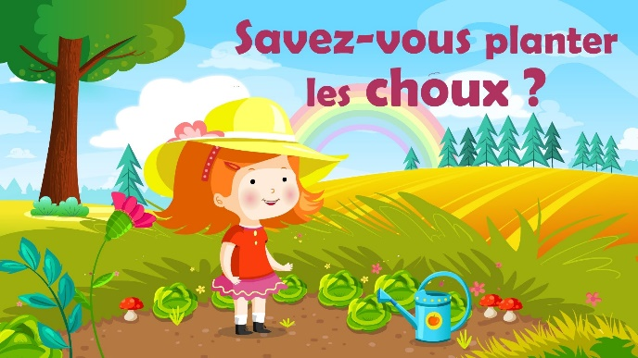
Savez-vous planter les choux?
https://www.youtube.com/watch?v=jVr8x1opYqg

Classroom displays from Pinterest:
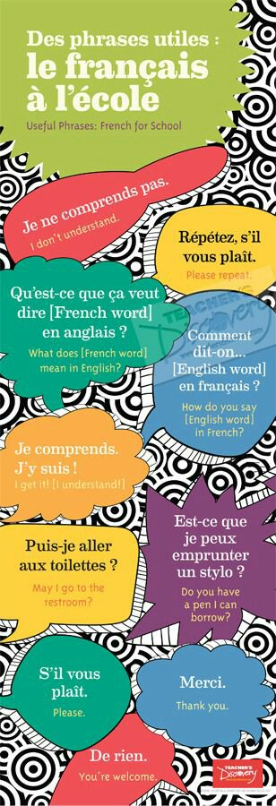

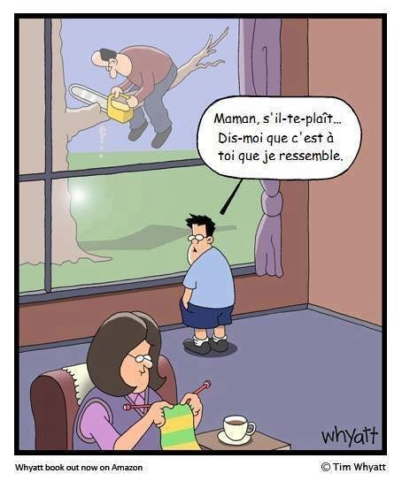
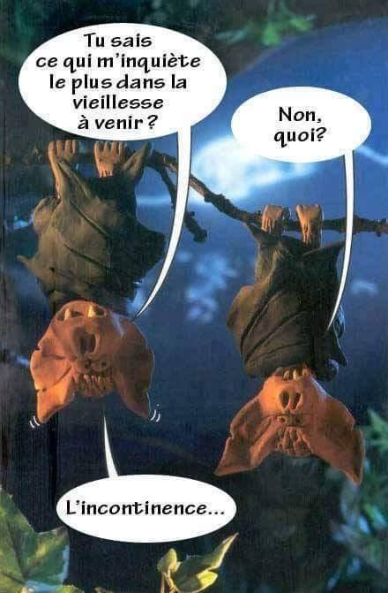

Maybe not one for the children !!!

And some fun ideas for Spanish
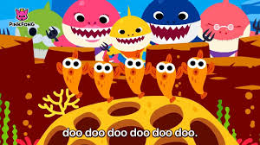

For those of you doing family members in Spanish, you might like to use this very catchy tune, “Baby Shark in Spanish”. Have searched and searched but not found a French version yet.

https://www.youtube.com/watch?v=QUIJ0zQavhE&feature=youtu.be

worksheet
RUTINA COMIENZO DE CLASE
BEGINNING OF CLASS ROUTINE
FREE

Rockalingua is a website dedicated to teaching children Spanish through music and song. There are lots of activities that are free - have a look.
https://rockalingua.com/videos
Why not work on those classroom routines in Spanish, and with a song?
https://rockalingua.com/videos/clean-up-routine
Simple classroom instruction in Spanish

(teacher says) Uno, dos, tres, ojos a mi (students say) Uno, dos, tres, ojos a ti
It rhymes in Spanish but not in English - 1,2,3 eyes on me, 1,2, 3 eyes on you

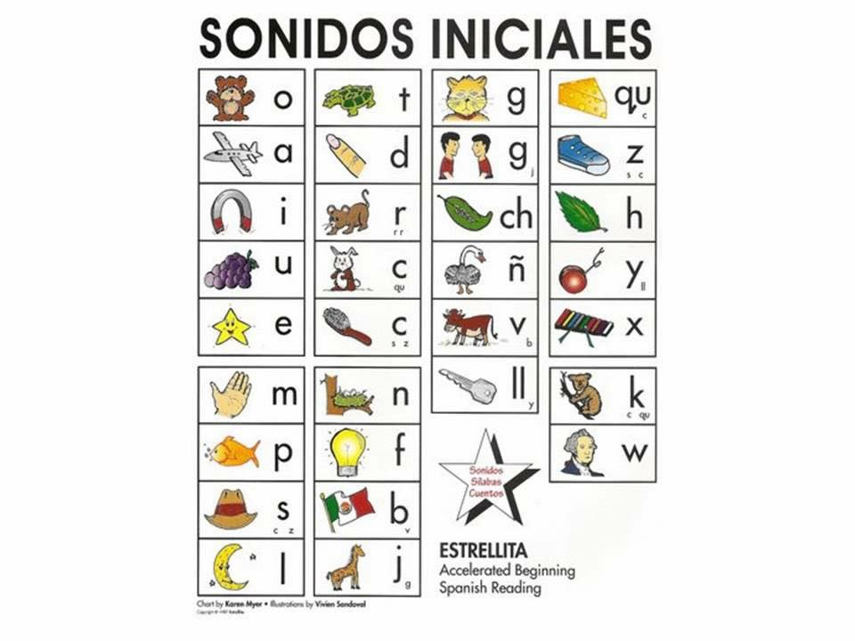

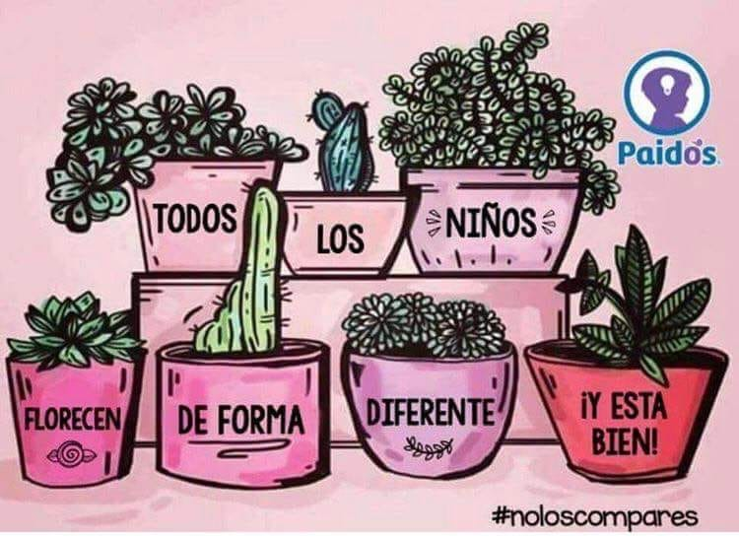

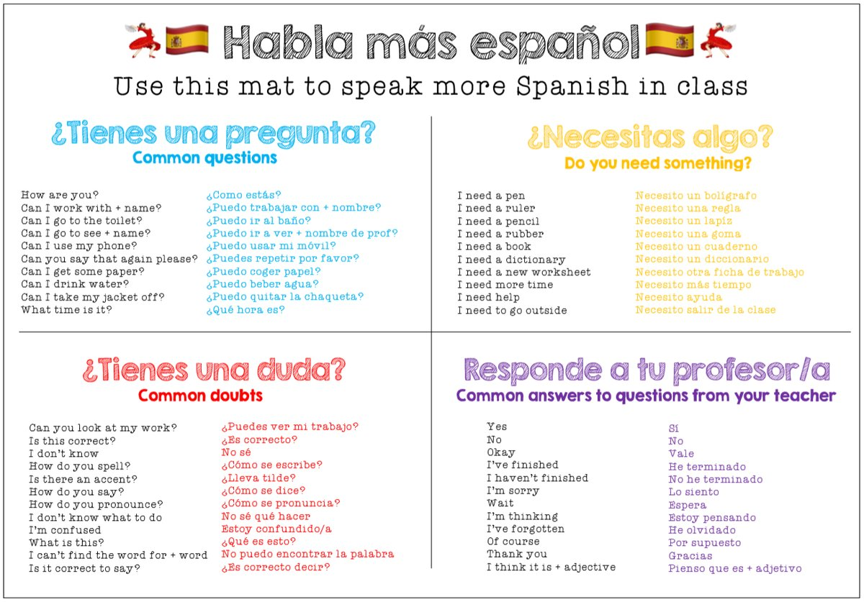

Couldn’t resist signing off with this ‘peach’ of a joke! Enjoy a fruitful and healthy autumn term - I look forward to catching up with lots of you at the next Hub meeting on 18 October,
Warm wishes, Liz.

